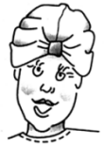

How-to
You’ll need a bit less to a bit more than 5/8 yard per turban, depending on the size. Cut one each of the three pieces (turban, band, and tab) according to the chart. Note that all sizes use the same size tab. You must use stretch knit fabric and cut the pieces using the crosswise grain. You can use a sewing machine zigzag stitch but serging is simplest and quickest. The seam allowance is approximately 1/2".
Cut Size | Turban | Band | Tab
Small | 20 1/2” x 8” | 20 1/2” x 5” | 5” x 4”
Medium | 22” x 9” | 22” x 5” | 5” x 4”
Large | 24” x 10” | 24” x 5” | 5” x 4”

Cutting
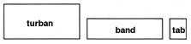

crosswise stretch of knit fabric

1. Fold the band in half lengthwise, wrong sides together. Serge it to one of the long sides of the turban piece, right side together.
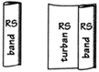
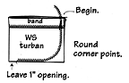
2. Fold the banded turban piece in half crosswise, right sides together. Serge, beginning at the banded edge, rounding off the back corner point, and stopping 1" before reaching the front folded edge. The tab will be inserted through this opening later. Secure thread tails and turn the turban right sides out.
3. Perpendicular to the back seam allowance fold up and pin three tucks approximately 3/4" deep. Stitch in the ditch of the seam allowance to secure these tucks. (If the fabric is too thick to stitch on your machine, hand-sew along the seam using a large needle and upholstery or quilting thread.)
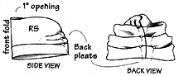
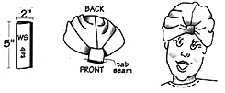
4. Fold the tab in half lengthwise, right sides together and serge the seam. Turn the tab right sides out and rotate it so that the seam is centered on the underside. Slip the tab through the opening in the turban seam. Fold up and stack tucks along the front seam from the lower band edge to the opening. (These tucks are similar to those at the back except they're stacked and not secured with stitching in the ditch.) Wrap the tab around the tucks and sew the tab ends by machine, right sides together. Rotate the tab seam allowance underneath the turban and tack it by machine to the center front seam allowance. This connection will prevent any see-through gap between the tab and the turban.
Note: We make mostly the medium size; the small size would fit a young teen. Vary the style with a contrast color band, especially if you’re short of fabric. The tab is a natural place for embellishment (fabric rose, pin, button, or bow.

