“Blessed is he who mingleth with all men in a spirit of utmost kindliness and love.”
–Baha’u’llah
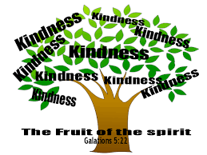

“Blessed is he who mingleth with all men in a spirit of utmost kindliness and love.”
–Baha’u’llah

“Blessed is he who mingleth with all men in a spirit of utmost kindliness and love.”
–Baha’u’llah

“Blessed is he who mingleth with all men in a spirit of utmost kindliness and love.”
–Baha’u’llah

