Ruhi Grade 1
Lesson 21: RADIANCE
Slightly modified from Ruhi Grade 1 material

PRAYERS
Prayer Sharers
Review Prayers
Review Prayer being memorized from Lesson 18 (“O my Lord! O my Lord! I am a child of tender years…”)

INTRODUCTION TO THE VIRTUE OF RADIANCE- Last time we talked about enkindlement- being on fire with the love of God. This virtue is related to it! We let the light of the love of God continue to enkindle our heart and it illumines our heart! As this light grows brighter and brighter, the warmth of our love and kindness becomes ever stronger. And those around us can feel the warmth of our love through our joyful and kind deeds and our bright and shining faces. They feel drawn to the glow that lights up our hearts.

To help us remember the importance of the quality of radiance, let us memorize the following quotation:

“O Son of Being! Thou art My lamp and My light is in thee. Get thou from it thy radiance and seek none other than Me.”

What does Baha’u’llah, who is speaking the Words of God to us, say that we are? We are like a lamp. What is in us? God’s light. When you look at this lamp- is it fulfilling its purpose (LAMP TURNED OFF and UNPLUGGED)? No- why not? It is a very pretty lamp. Oh- but what is it made to do? Not just be pretty. It is made to give off light! So, let’s plug it into the source of light… then what happens? It can fulfill its purpose. Now is it doing what it was made to do? YES! We are the same way. When we connect with God through His Manifestations- one in each age- they are like this cord and they connect us to that invisible source, and we can fulfill our purpose to know and to love God and to shine out like a lamp in the darkness of this world with the light of the love of God!

Get thou from it thy radiance and seek none other than Me.

Radiance
1. Sometimes, when we leave a dark room and go outside, we have to cover our eyes until they get used to the bright light. We have to shield our eyes from the radiance of the sun.
2. Mrs. Santos loves everyone like her own family. She is always generous, kind and helpful towards others. The love in her heart is felt by all the people she meets, bringing them joy. Everyone is touched by her radiance.

Our radiance should come from God’s light within us. And Baha’ullah says we should seek none other than God. Let’s look at the word “seek”

Seek
1. When a baby bird hatches, the mother will look for food to feed it. The mother bird will seek food for the new chick.
2. The school invited all the students on a special outing. In order to attend, they needed their parents’ permission. All the students were asked to seek approval from their parents to go on the outing.

What should we seek? None other than God. What does that mean? God has created us rich in virtues- in spiritual gifts and with much generosity given us the ability to reflect and shine out God’s light. This is what we should spend our precious lives doing and be sure that in all that we do, we are doing that. Make sure that is the thing we are seeking to do. Some people seek fame. This life is not about being famous. Some people seek riches. It is not about being rich. This life is about being instruments- just like a lamp is- to shine God’s light out in the world to those we meet. Its fine to be famous. Its fine to be rich. But that is not our goal. Our goal is to be a light in the world in whatever we are doing!

REPEAT QUOTE several times

SONGS: (see www.supportingthecoreactivities.org under this lesson for the songsheets)
- Siyahamba
- Radiance
- Flame of the Love of God
- This Little Light of Mine
- Thou Art My Lamp

Siyahamba
Siyahamb’ ekukhanyen’ kwenkhos x4
CHORUS:
Siyahamba, hamba, Siyahamba, hamba

Siyahamb’ ekukhanyen’ kwenkhos
Siyahamba, hamba, Siyahamba, hamba
Siyahamb’ ekukhanyen’ kwenkhos
We are marching in the light of God x4
We are marching, marching x2
We are marching in the light of God
We are marching, marching x2
We are marching in the light of God
Siyahamb’ ekukhanyen’ kwenkhos x4
CHORUS
We are singing as one family x4
CHORUS

Story about Radiance

Dorothy Baker was a noble and distinguished lady and one of the great figures of the Bahá’í Faith. When she was a young girl, she had the honor of meeting ‘Abdu’l-Bahá during His travels in the West. She was so drawn to His radiance and love that she longed to follow in His footsteps.

It was Dorothy’s grandmother, Ellen Beecher, who took her to meet ‘Abdu’l-Bahá. Arriving at a house that she had never been to before, Dorothy entered a room in which many people were talking quietly and reverently while waiting for ‘Abdu’l-Bahá to speak. ‘Abdu’l-Bahá smiled at Mrs. Beecher as they came in the room and motioned to the young Dorothy to sit near Him. Dorothy was a very shy child. Without looking up from the floor, she carefully walked past the people who were sitting around Him to reach the footstool near His feet.

While ‘Abdu’l-Bahá spoke, she sat with her eyes down, staring at her black shoes. He did not look at her, and she did not have the courage to look at Him. Dorothy was nervous and continued looking down, afraid of the unknown. But gradually she relaxed, and soon her fear was gone. A feeling of deep longing had come over her. She was filled by a strong desire for her soul to be lost in the greatness of ‘Abdu’l-Bahá’s love. She was touched by His radiance, wrapped in the warmth of His presence.

Dorothy’s fear had been replaced by a greater force. She could not imagine being separated from ‘Abdu’l-Bahá for even one moment. His loving eyes seemed to speak to her, telling her of the spiritual worlds of God. His radiance was magnetic. Without even realizing that she had moved, Dorothy found herself turned in His direction, with her elbows on her knees and her chin in her hands, gazing at ‘Abdu’l-Bahá’s luminous face.

Dorothy could not remember what ‘Abdu’l-Bahá spoke about that day. All she could remember was His kind face, His melodious voice, and the warmth of His presence. The love she had in her heart was so strong that at last she decided to write a letter to ‘Abdu’l-Bahá. In her letter, she begged Him to let her serve Him and the Cause of His Father, Bahá’u’lláh. In His answer to Dorothy, ‘Abdu’l-Bahá praised her goal, assured her of God’s bounties: "My hope is this: that you will succeed in your desire". And, indeed, Dorothy dedicated her entire life to serving God and humanity.
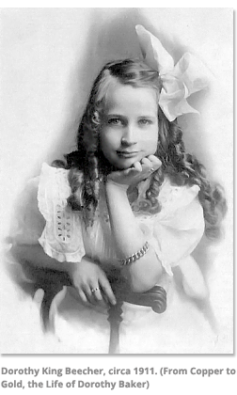 | 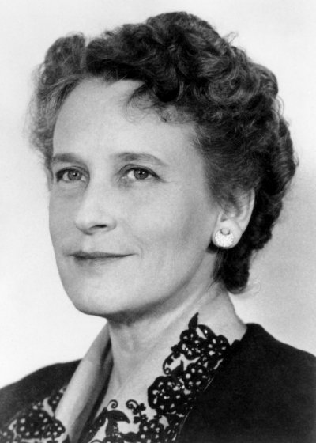
COOPERATIVE GAME: Cooperative Musical Pillows

ARTS and CRAFTS:
Decorate lamp with tissue paper and verse “Thou art My lamp and My light is in thee…”

Instructions: Get modge podge and cut squares of tissue paper and have the children put around the outside of a lamp-like candle holder (one candle holder for each child). Modge podge the verse, which is cut into the appropriate size, onto the top of the tissue paper that is glued. Then put a battery-operated tea-lamp inside it.

Coloring sheet

