RUHI GRADE 1, LESSON 8 ON SINCERITY
Slightly modified from Ruhi Book 3 curriculum

PRAYERS
Open the class by saying a prayer you know by heart, and then ask some of the children to recite prayers.

Review “O Lord, I am a child” prayer
Teach “Blessed is the Spot”

“Blessed is the spot, and the house, and the place, and the city, and the heart, and the mountain, and the refuge, and the cave, and the valley, and the land, and the sea, and the island, and the meadow, where mention of God hath been made and His praise glorified.” –Baha’u’llah

Play Blessed is the Spot

DESCRIPTION OF VIRTUE AND MEMORIZATION
The virtue we are learning about today is SINCERITY

When our words and deeds reflect what is in our hearts, we show forth the quality of sincerity. Sincerity inspires us to be truthful and faithful in our dealings with others. For example, when we say that we are sorry for something that we have done, we also know in our hearts that we will really try to do better. It is through our sincerity that others can see the purity of our hearts and place their trust in us.

STORY:
Sometimes, we can better understand what it means to possess a quality by listening to a story that shows when it is lacking.

For many years a large tree stood behind a house that belonged to a husband and wife with several children. As the tree grew, its branches reached up and out, shading the back of the family’s home. One winter morning, the father was passing under the tree when he met a neighbour.

They spoke briefly of the comings and goings in the village. After a while, the neighbour, taking notice of the large tree, said to the man, “You know, it really is time for you to cut that enormous tree down. It is sprawling and unruly. What if one of the branches were to break off and fall onto your roof—or worse yet, hit one of your children while they play in the shade?”

When the two had parted, the man considered his neighbour’s advice. The tree had stood in this place since before he could remember, and no harm had come of it. It gave good shade in the summer and shielded the house from the bitter winds of winter. It seemed sturdy and strong. “Still, perhaps my neighbour has a point,” the man said to himself. “Appearances can sometimes be deceiving. What if the tree is not as sturdy as it seems?” And so he decided to cut it down.

It was a difficult job, for the tree was very big, indeed, and had many limbs and branches, some of them quite high. Just as the man finished, his neighbour returned, this time accompanied by his two sons and a cart. “I see you decided to take down the tree,” the neighbour said, looking at the many stacks of wood. “I suppose you’ll need someone to take those piles away. Perhaps we can help you. I have brought my cart and my two sons, and we will be happy to remove all this from your yard.” Without waiting for an answer, the sons began loading the wood into the waiting cart.

As they pulled away, the man sat down on the stump of the tree that had sheltered his home for so long. It was then that he realized that his neighbour had not been concerned for his family’s safety after all, but for the supply of firewood that would keep him warm through the winter months. “Appearances can, indeed, sometimes be deceiving,” he said with a sigh.

LESSON CONTINUED:
To understand the concept of sincerity, let’s look at the opposite of sincerity, which is to be “fake”.

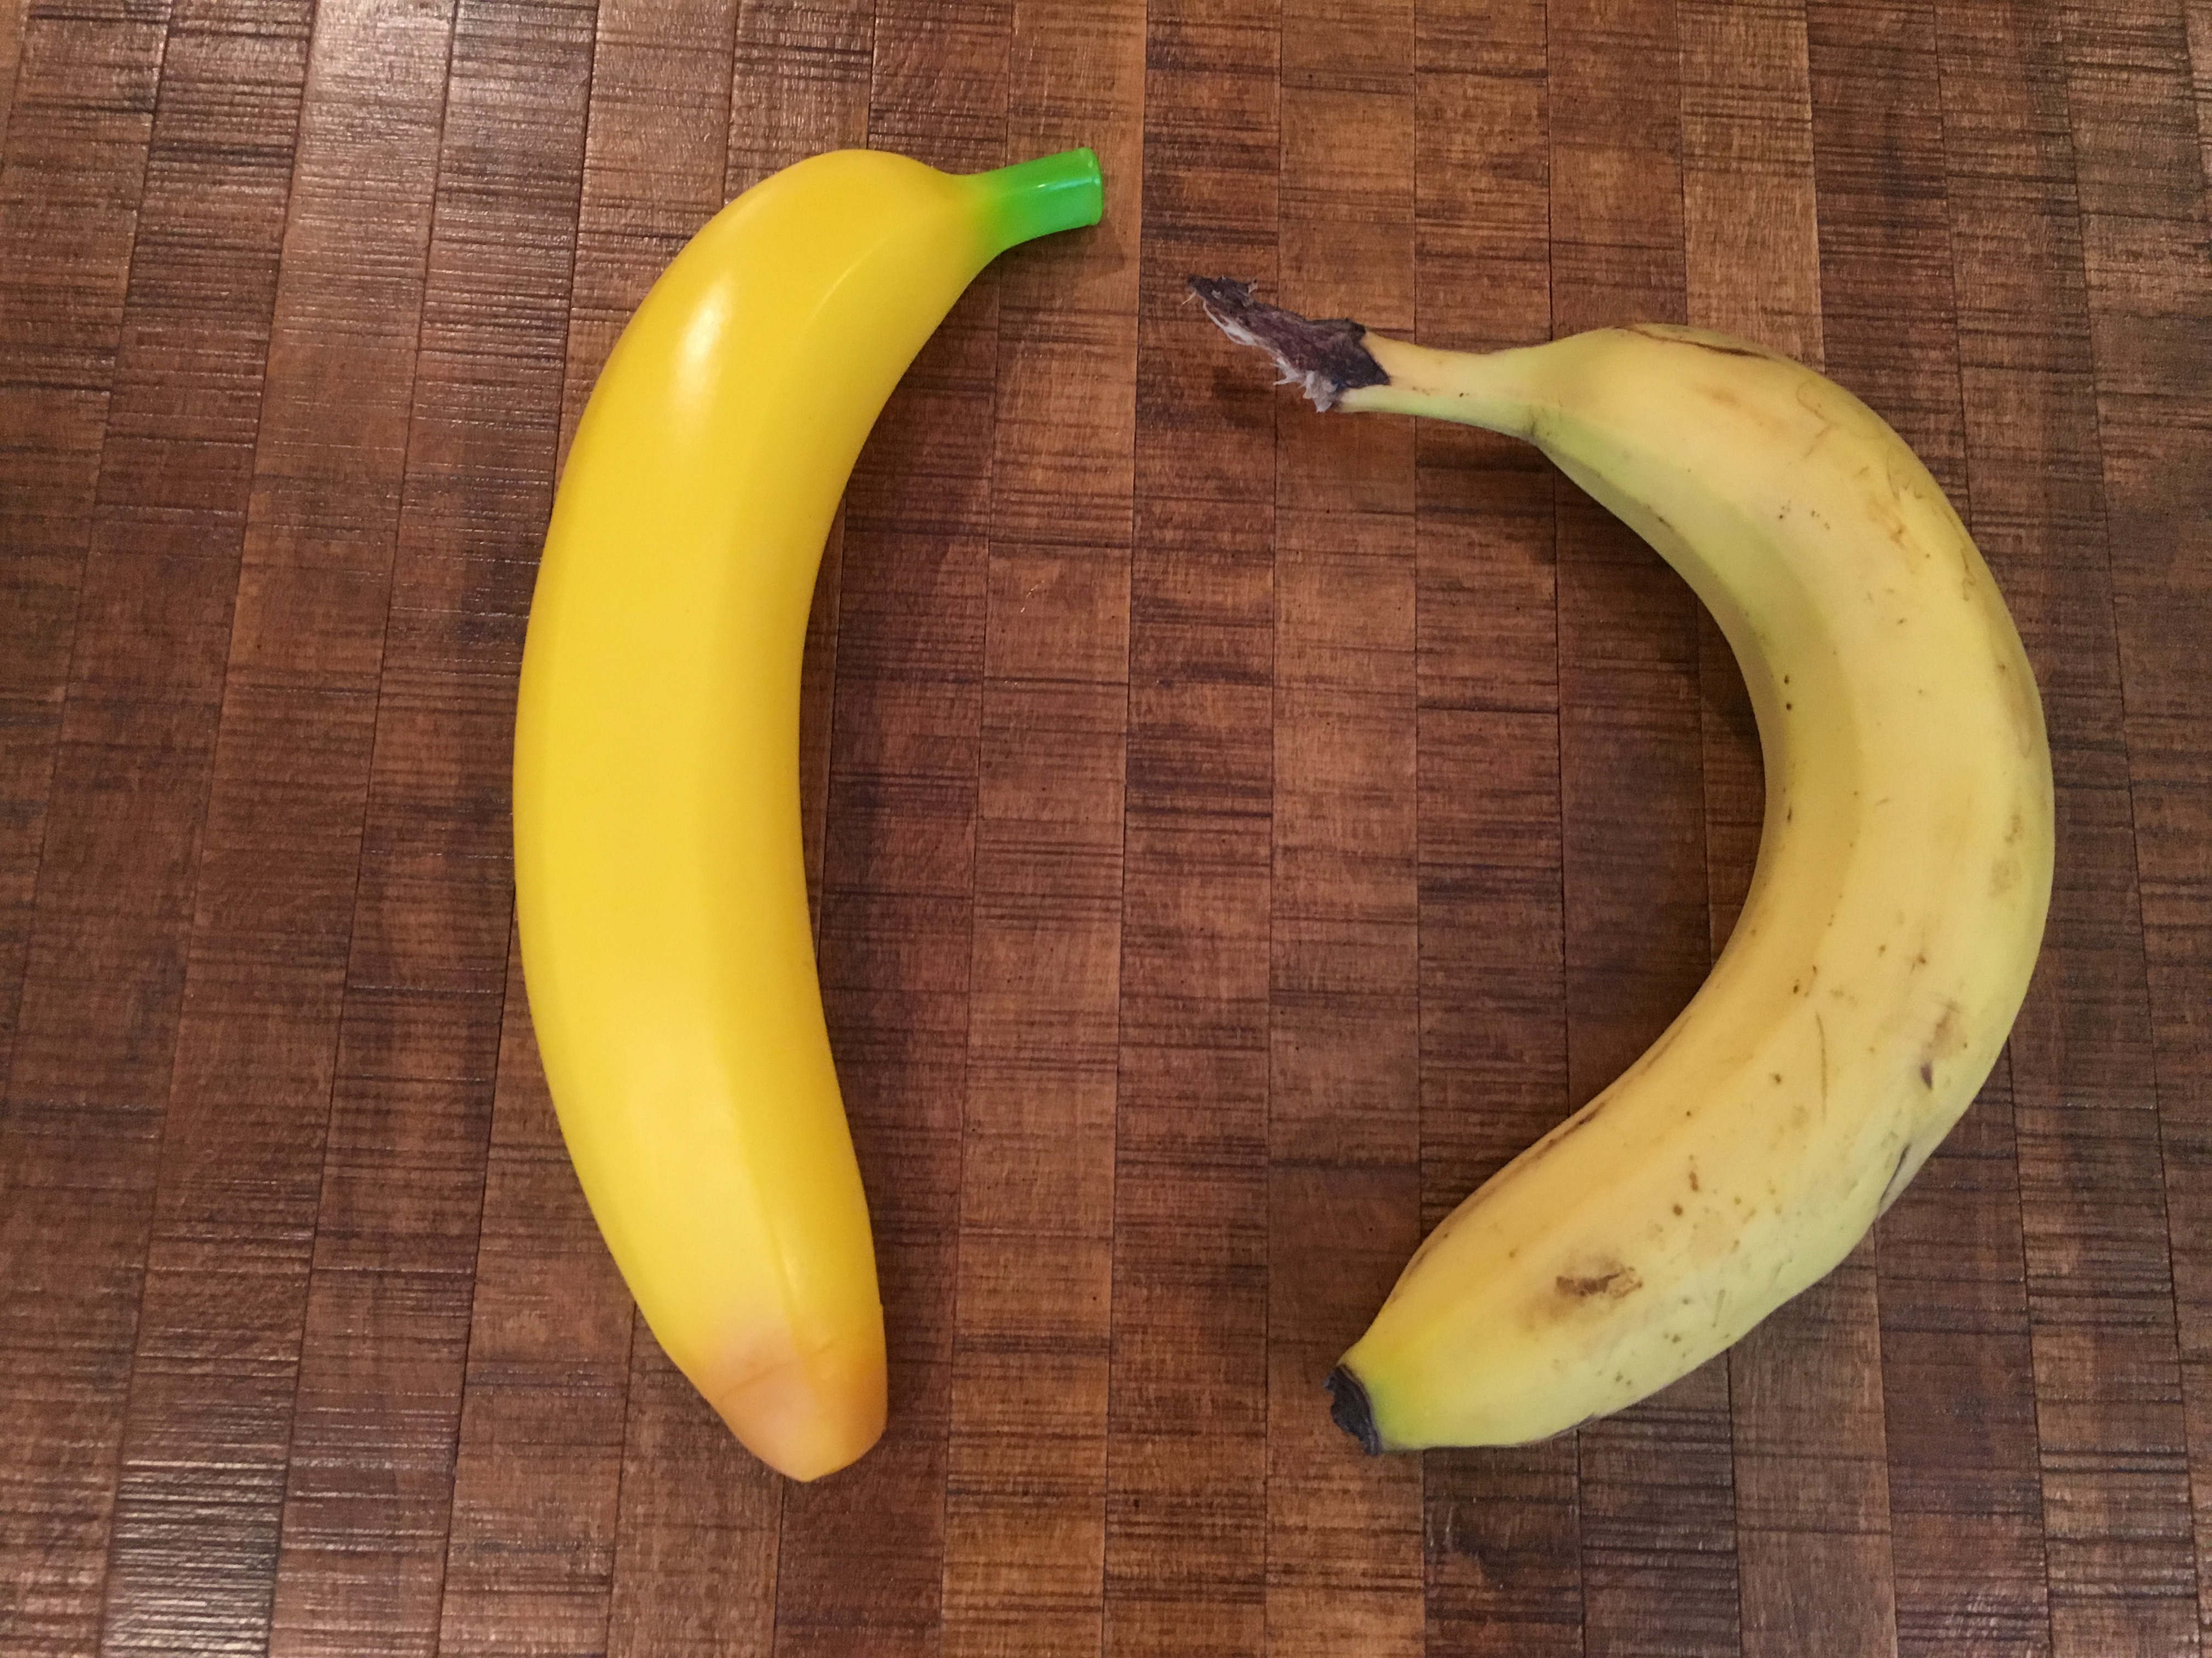
Compare a real banana and a fake banana: The fake banana may look a little bit prettier on the outside and have no dents or bruises, but when you look down to the essence of what it is, it doesn’t have the same value. Taste good? Help us to grow? Give us good nutrition? Bear more fruit?

So it is much more helpful for us if we have the real thing.



Next: When you look at pictures on the magazines, people are often air brushed, and when it comes to the way we look, sometimes people think that this is the way we should look, but a lot of times these images are fake- what we see isn’t real life. -> We were created by God to be exactly who we are. God didn’t make mistakes. To wish we could live in a fake world of perfect bodies and perfect complexions is not the way God intended us to live. Its okay to look the way we really do and to be a work in progress, to be striving and struggling sometimes.

Sometimes just like things can be fake or real, people can act fake or real. Bad example. Example- (with other teacher) say something nice to their face, ask them to go away (within ear shot) and say the opposite thing to the other person.
An example would be, “Genny, I like your shirt.” She then walked away, and I said to Kenzie, “I don’t really like her shirt at all.”

“Be ye sincerely kind, not in appearance only.”

Wow, Genny. That’s a really cool shirt. (leaves) “She really has a cool shirt on!”

**While you are all probably very sincere, not everyone is. Your parents help protect you from people who are not sincere. **

MEMORIZATION: To help us remember the importance of sincerity- being real and coming from the heart, let’s memorize the following quotation of ‘Abdu’l-Bahá:

“We should at all times manifest our truthfulness and sincerity…”

Manifest
1. Asha cleaned the mud off the seashall that he found at the beach and polished it until it was smooth and shiny. When he was finished, the shell’s true beauty became manifest.
2. As the sun rose and the morning fog lifted, the splendour of the mountains became manifest.

Sincerity
- Leo’s classmates often play games instead of studying. Leo is worried that they will not do well in school, so he suggests that they all study together and tries to think of ways that they can help each other learn. Leo’s concern for his classmates is sincere.

2. Rosa promised her mother that she would do her homework every day. When her parents are away, Rosa diligently works on her homework assignments. Rose was sincere in her promise.

(DO MOVES TO QUOTES)

GAMES:
DIVIDE GROUP INTO 2 FOR GAMES
Game: "Hot or Cold"
Begin by instructing one of the children to leave the room or to go some distance from the area where the class is being held. The others hide a small object e.g. pencil, and the child is asked to come back into the classroom and to find that small object. The others help by clapping louder and louder/saying warm/warmer as the child comes closer to the object, and clapping more quietly or saying colder/cold as the child moves away. The children should be careful not to mislead the friend who is searching for the hidden object; otherwise he or she will lose trust in the others, and the game will be futile.

Puzzles or Tower

SONGS:
Honesty- I say what I mean I mean what I say by Jennifer Russell n This is Where I Live CD

Yes I Believe You (http://www.ruhi.org/resources/songs.php)

I am a Bucket Filler by Red Grammer (https://www.redgrammer.com/index.php/i-am-a-bucket-filler-song.html)

COLORING/CRAFT: Coloring sheet- can do Ruhi Grade 1 coloring sheet of tree, can also do mandala coloring sheet- emphasizing that we do what we say and that when you are coloring make each side mirror exactly the other side as a symbol of that.

(Can also read the Emperor’s New Clothes by Hans Christian Andersen, pictures by Virginia Lee, if have time. Other alternative stories include The Fox and the Crow and Grandpa’s Teeth by Rod Clement.)

