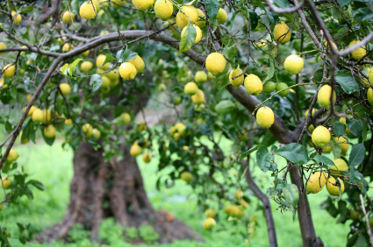

“O Son of Man! Humble thyself before Me, that I may graciously visit thee.”
-The Bahai Sacred Writings

“O Son of Man! Humble thyself before Me, that I may graciously visit thee.”
-The Bahai Sacred Writings

“O Son of Man! Humble thyself before Me, that I may graciously visit thee.”
-The Bahai Sacred Writings

“O Son of Man! Humble thyself before Me, that I may graciously visit thee.”
-The Bahai Sacred Writings

“O Son of Man! Humble thyself before Me, that I may graciously visit thee.”
-The Bahai Sacred Writings

