Ruhi Grade 1, Lesson 2: JUSTICE
Slightly modified from Ruhi Grade 1 Curriculum

Excellent resource for lesson on justice:
http://core-activities.weebly.com/cc-grade1/grade-1-lesson-2-justice

Opening Prayers:

Point out prayer section in their albums. Ask for two prayer sharers to share a prayer.

Then share the following prayer, inviting others to turn to that page and follow along. "Say O God! Attire mine head with the crown of Justice, and my temple with the ornament of equity. Thou, very, art the Possessor of all gifts and bounties."
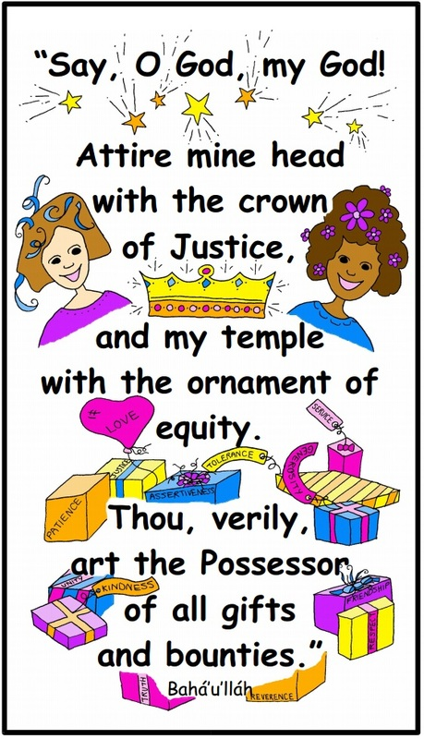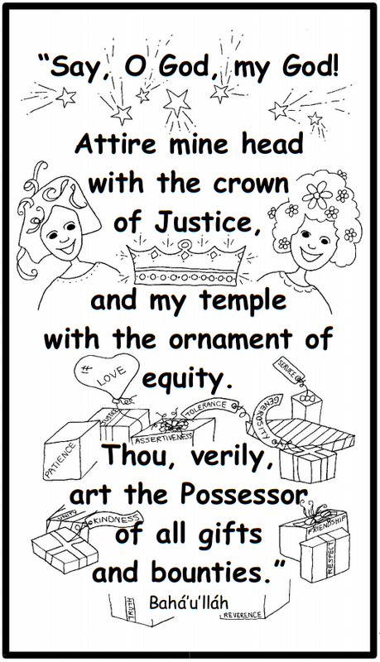

Based on the prayer I said, can anyone guess what virtue we are going to learn about today? JUSTICE

What is justice?
Practicing justice is being fair in everything you do. It is seeing with you own eyes and not judging something or someone by what other people tell you. (what if someone pointed out a person on the playground and said- Oh that girl is wierd. How could you practice justice and be fair in that situation? Would it be right not to play with her?)

Justice also means that people receive what they deserve. Everyone gets his fair share. (pass out clay of different sizes to children- then ask- Do you think I distributed them fairly? What could be done so that it is fair and just? Have them do that (share so that the clay pieces are close in size)

Show symbol of justice- lady blindfolded with scales
Bring out scales,
Put rice on scale- then ask them to tell you when it is equal. (kids can take turns putting one spoonful on at a time). Now, I am going to keep this rice on this side, but for this side I am going to put these jewels. Let’s pretend they are precious jewels!
Take off rice and put jewels on one side and rice on the other. Are these equal? Yes- in weight. But what about in value? If you needed money to pay for a house for your family, which would be more valuable? (jewels- could sell them). What if you were stranded on a deserted island and were starving to death? Which one would be more valuable? So equal doesn’t always mean the same.

Let’s look at the picture of the exam- (for a fair exam let’s all take the same test cartoon). Is that a just and fair test? Why not? What about the second image (all standing to see game- given box of same height cartoon, then differing boxes according to needs). When you practice justice, you treat each person as an individual. You see them one by one. People who are unjust are often prejudiced. They judge people by their looks and make beliefs based on them. All people from India are like this… all white people are like that… Is that fair?

Without justice, people who hurt or take advantage of others get away with it and keep on doing it. Without justice the world can be a cruel and dangerous place. People are judged or treated differently because they are a girl instead of a boy, have different color skin, believe in a different Messenger of God. In fact, right now many people are suffering in this world because of injustice. In some countries, girls are not allowed to go to school just because they are girls and the people in power think boys are more important. Is that just? Or in some places people are not allowed to practice their religion just because the people in power believe that their religion is the right one? They are not even allowed to gather together to say prayers! Is that fair? We need justice in order to protect the rights of everyone.

Sometime being just means standing up for your rights and the rights of other people. If someone is picking on someone, being just may mean standing up for them and saying that they are your friend and deserve to be treated kindly. Sometimes, just like with the clay, to be just we have to share what we have with others.

When you are being just, you stand up for yourself, and for others. You don't accept it when someone acts like a bully, cheats, or lies. Being a champion for justice takes courage. Sometimes when you stand for justice, you stand alone. God is always with you, though, and He is so please when He sees us treating other people with fairness and justice.

Learn Quote:
In order to help us be just, let us memorize this quotation of Baha'u'llah:

"Tread ye the path of justice, for this, verily, is the straight path."

Tread
1. Many leaves have fallen from the trees in the forest, covering the path. Juliette walks through the forest. She treads the leaf-covered path.
2. Pedro like to help all his friends play happily together. Pedro and his friends are very unified. Pedro treads the path of unity.

Path
1. Luis lives on a farm and his family owns a donkey. He took it to graze in a meadow and left it alone. The donkey found the path home by itself.
2. There are two ways to go to school. Millie always likes to take the path that goes by her grandmother's house.

Justice
1. Carlos was given crayons to hand out during class. There were ten crayons and five children. Carlos gave two crayons to each child. Carlos was acting with justice in handing out the crayons.

2. Anna has lots of food in her pantry, but sometimes a lady that she knows who has many children does not have enough money to buy food. Anna never allows this neighbour to suffer and always makes her feel welcome to come over for dinner. Anna loves justice.

PLAY SONG of quote put to music
https://app.box.com/s/9isrkzdzupdkep3cp56t

SONG:

A Noble Way
Justice is a noble way
Justice brings a brighter day
A light to those in need
Shining through good deeds
Oh, justice is the way.

We know 'Abdu'l-Baha would share
Showing love and showing care
He was content with less
In order to bring happiness
He was content with less

To be just we have to give,
Share our love and joy to live
Sharing blessing we receive
A better world we will achieve
Oh, justice is the way.

Story: One day, 'Abdu'l-Baha wanted to go from 'Akka to Haifa.
He went to take an inexpensive seat in a regular coach.
The driver was surprised and must have asked himself why 'Abdu'l-Baha
was so frugal as to ride in this cheap coach. "Surely, Your Excellency would
prefer to travel in a private carriage," he exclaimed. "No," replied the Master
and He traveled in the crowded coach all the way to Haifa.
As He stepped down from the coach in Haifa, a distressed fisher woman came
to Him and asked for His help. All day she had caught nothing
and now had to return home to her hungry family.
'Abdu'l-Baha gave her a good sum of money, turned to the driver and said,
"Why should I ride in luxury while so many are starving?"

ART ACTIVITY- justice jars- Make justice jars using mason jars, brushes, small squares of tissue and modge podge. You will also need a quote about justice cut and then mounted on colored paper which then will be attached to a piece of string around the mouth of the jar. On the lid it can say the name of the child and that it is his justice jar. Please see pictures on www.supportingthecoreactivities.org These justice jars can be used for collecting coins for donating to the poor

Also have a coloring sheet for when you are finished.

If there is time, play the following GAME:

It's Fair to Share Game
On individual slips of paper write down the name of things or animals such as: bird, bunny, peanut butter and jelly sandwich, candy bar, TV remote, basketball, brush etc. Prepare a few more slips of paper then the number of children in the class.

One child draws a slip out of a basket and reads it to them self and sets it aside without saying it out loud. If there are non readers in the class they can draw and a teacher can whisper what it says in their ear. The child pretends they have this imaginary thing for a few seconds and then pass it to the person next to them. For example if it said "bunny" they might cradle it in their arm gently, pet it a couple times and pass it to the next person carefully. If it said "hair brush" they might pretend to brush their hair a couple times and pass it to the next person. If it's a sandwich they might hold it like a sandwich, take a big bite and pass it to the next person. The item continues around the circle like that person to person.

The only talking is when the object is handed from one person to the next the receiver says "Thanks for sharing" and the giver says "You're welcome". Everyone copies what the first child did even though they might not know what the object/animal is suppose to be. When the object has made it back to where it started everyone else in the group makes one guess as to what it was they think they all just shared. The person who started the round tells everyone what it actually was. Let everyone have a turn being the first.]

End with closing prayer.

Can also give them a justice word search to take home.

