**“Tread ye the path of justice, for this, verily, is the straight path.”**

**-Baha’u’llah**

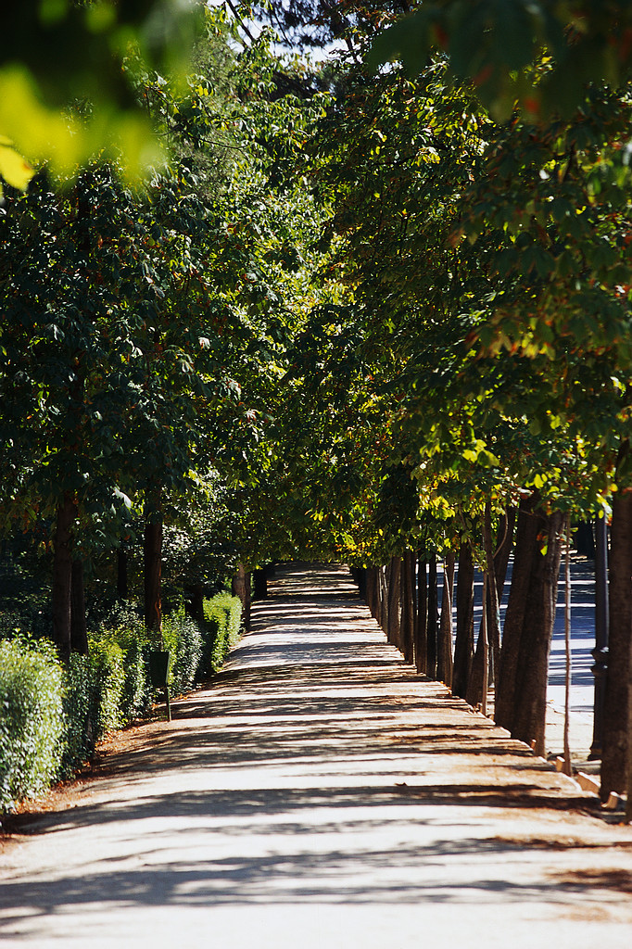

**“Tread ye the path of justice, for this, verily, is the straight path.”**

**-Baha’u’llah**



**“Tread ye the path of justice, for this, verily, is the straight path.”**

**-Baha’u’llah**



**“Tread ye the path of justice, for this, verily, is the straight path.”**

**-Baha’u’llah**

