**“God is sufficient unto me; He verily is the All-sufficing! In Him let the trusting trust.”**

**-The Bab**

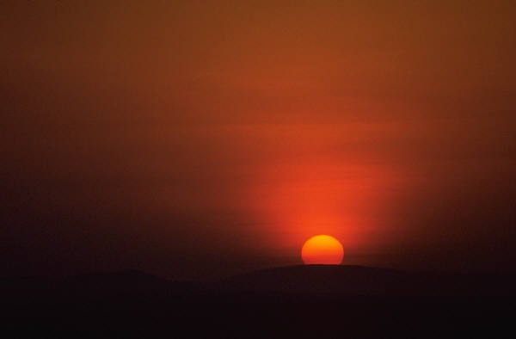

**“God is sufficient unto me; He verily is the All-sufficing! In Him let the trusting trust.”**

**-The Bab**



**“God is sufficient unto me; He verily is the All-sufficing! In Him let the trusting trust.”**

**-The Bab**



**“God is sufficient unto me; He verily is the All-sufficing! In Him let the trusting trust.”**

**-The Bab**

