**“O Lord God! Make us as waves of the sea, as flowers of the garden, united, agreed through the bounties of Thy love. O Lord! Dilate the breasts through the signs of Thy oneness, and make all mankind as stars shining from the same height of glory, as perfect fruits growing upon Thy tree of life. Verily, Thou art the Almighty, the Self-Subsistent, the Giver, the Forgiving, the Pardoner, the Omniscient, the One Creator.”**

**-Abdu'l-Baha**

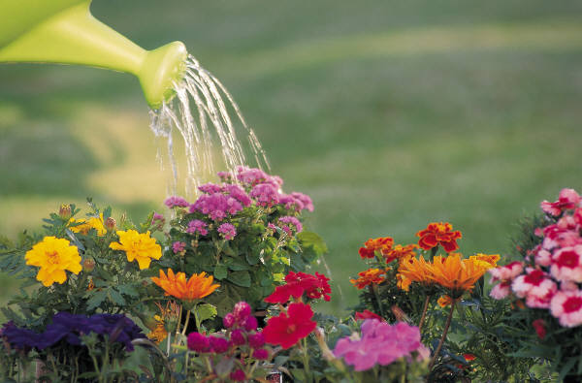

**“O Lord God! Make us as waves of the sea, as flowers of the garden, united, agreed through the bounties of Thy love. O Lord! Dilate the breasts through the signs of Thy oneness, and make all mankind as stars shining from the same height of glory, as perfect fruits growing upon Thy tree of life. Verily, Thou art the Almighty, the Self-Subsistent, the Giver, the Forgiving, the Pardoner, the Omniscient, the One Creator.”**

**-Abdu'l-Baha**



**“O Lord God! Make us as waves of the sea, as flowers of the garden, united, agreed through the bounties of Thy love. O Lord! Dilate the breasts through the signs of Thy oneness, and make all mankind as stars shining from the same height of glory, as perfect fruits growing upon Thy tree of life. Verily, Thou art the Almighty, the Self-Subsistent, the Giver, the Forgiving, the Pardoner, the Omniscient, the One Creator.”**

**-Abdu'l-Baha**



**“O Lord God! Make us as waves of the sea, as flowers of the garden, united, agreed through the bounties of Thy love. O Lord! Dilate the breasts through the signs of Thy oneness, and make all mankind as stars shining from the same height of glory, as perfect fruits growing upon Thy tree of life. Verily, Thou art the Almighty, the Self-Subsistent, the Giver, the Forgiving, the Pardoner, the Omniscient, the One Creator.”**

**-Abdu'l-Baha**

