Ms. Jaleh’s Book of
Prayers and Holy Writings

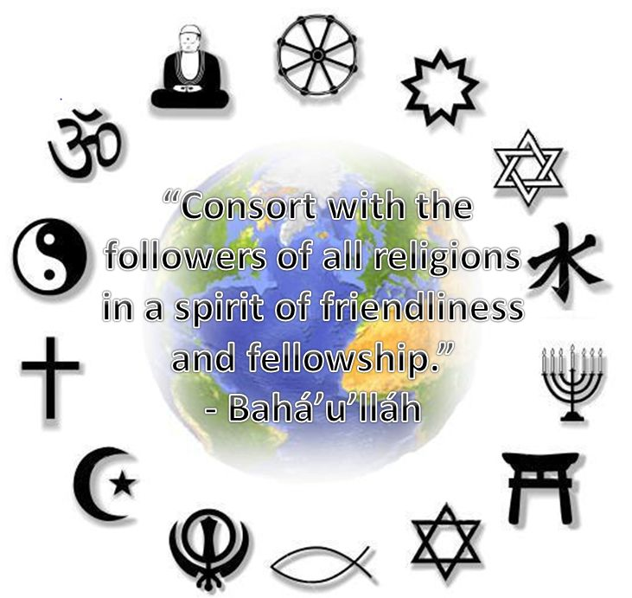

“It is clear and evident… that all the Prophets
are the Temples of the Cause of God,
Who have appeared clothed in diverse attire.
If thou wilt observe with discriminating eyes,
thou wilt behold Them all abiding
in the same tabernacle,
soaring in the same heaven,
seated upon the same throne,
uttering the same speech,
and proclaiming the same Faith.” – Baha’u’llah

Smriti’s Book of
Prayers and Holy Writings

“It is clear and evident… that all the Prophets
are the Temples of the Cause of God,
Who have appeared clothed in diverse attire.
If thou wilt observe with discriminating eyes,
thou wilt behold Them all abiding
in the same tabernacle,
soaring in the same heaven,
seated upon the same throne,
uttering the same speech,
and proclaiming the same Faith.” – Baha’u’llah

