Emily’s Book of
Prayers and Holy Writings

“…strive to translate that which
hath been written into reality
and action… The Great Being saith:
Blessed and happy is he that ariseth
to promote the best interests of the
peoples and kindreds of the earth.”
-The Bahai Writings

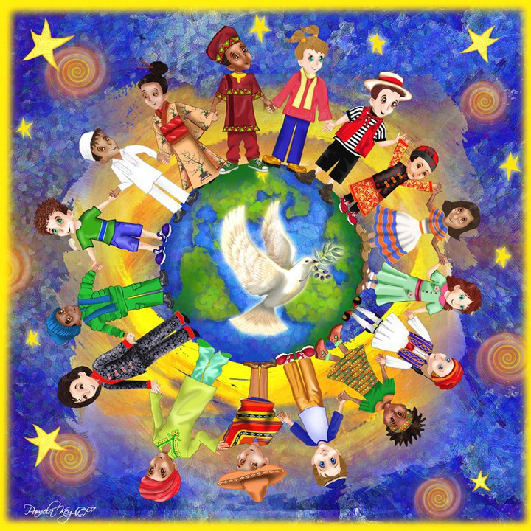
Brandon’s Book of
Prayers and Holy Writings

“…strive to translate that which
hath been written into reality
and action… The Great Being saith:
Blessed and happy is he that ariseth
to promote the best interests of the
peoples and kindreds of the earth.”
-The Bahai Writings

