Ms. Julie’s Book of
Prayers and Holy Writings

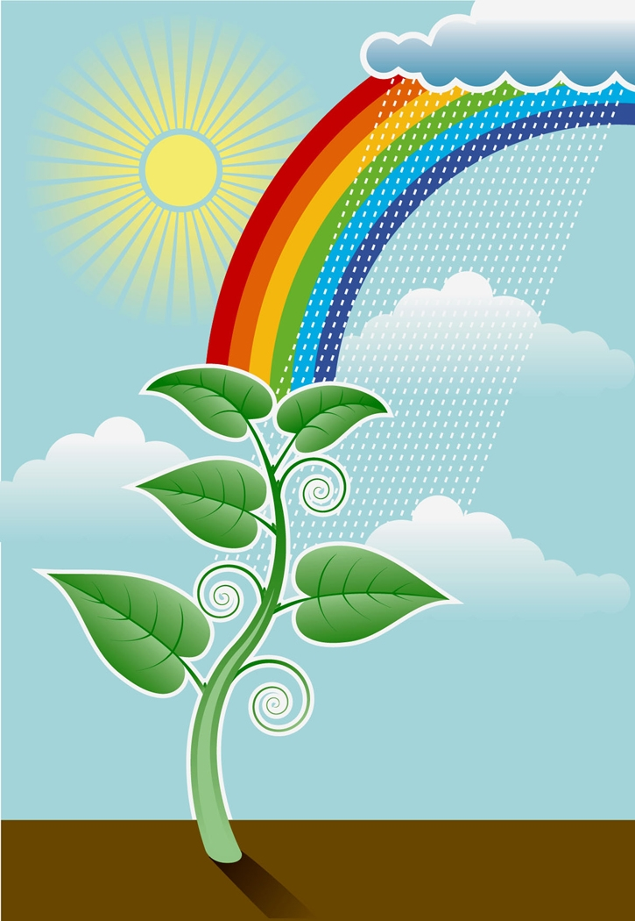

“These children are even as young plants, and teaching them the prayers is as letting the rain pour down upon them, that they may wax tender and fresh, and the soft breezes of the love of God may blow over them, making them to tremble with joy.”
-The Bahai Writings

