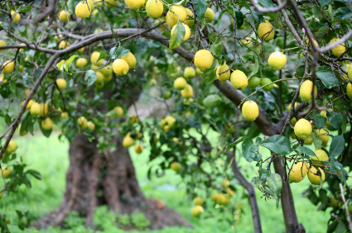

**“O Son of Man! Humble thyself before Me, that I may graciously visit thee.”**

-The Bahai Sacred Writings



**“O Son of Man! Humble thyself before Me, that I may graciously visit thee.”**

-The Bahai Sacred Writings



**“O Son of Man! Humble thyself before Me, that I may graciously visit thee.”**

-The Bahai Sacred Writings



**“O Son of Man! Humble thyself before Me, that I may graciously visit thee.”**

-The Bahai Sacred Writings

**“O Son of Man! Humble thyself before Me, that I may graciously visit thee.”**

-The Bahai Sacred Writings