Bahai
Children’s Class
Songbook
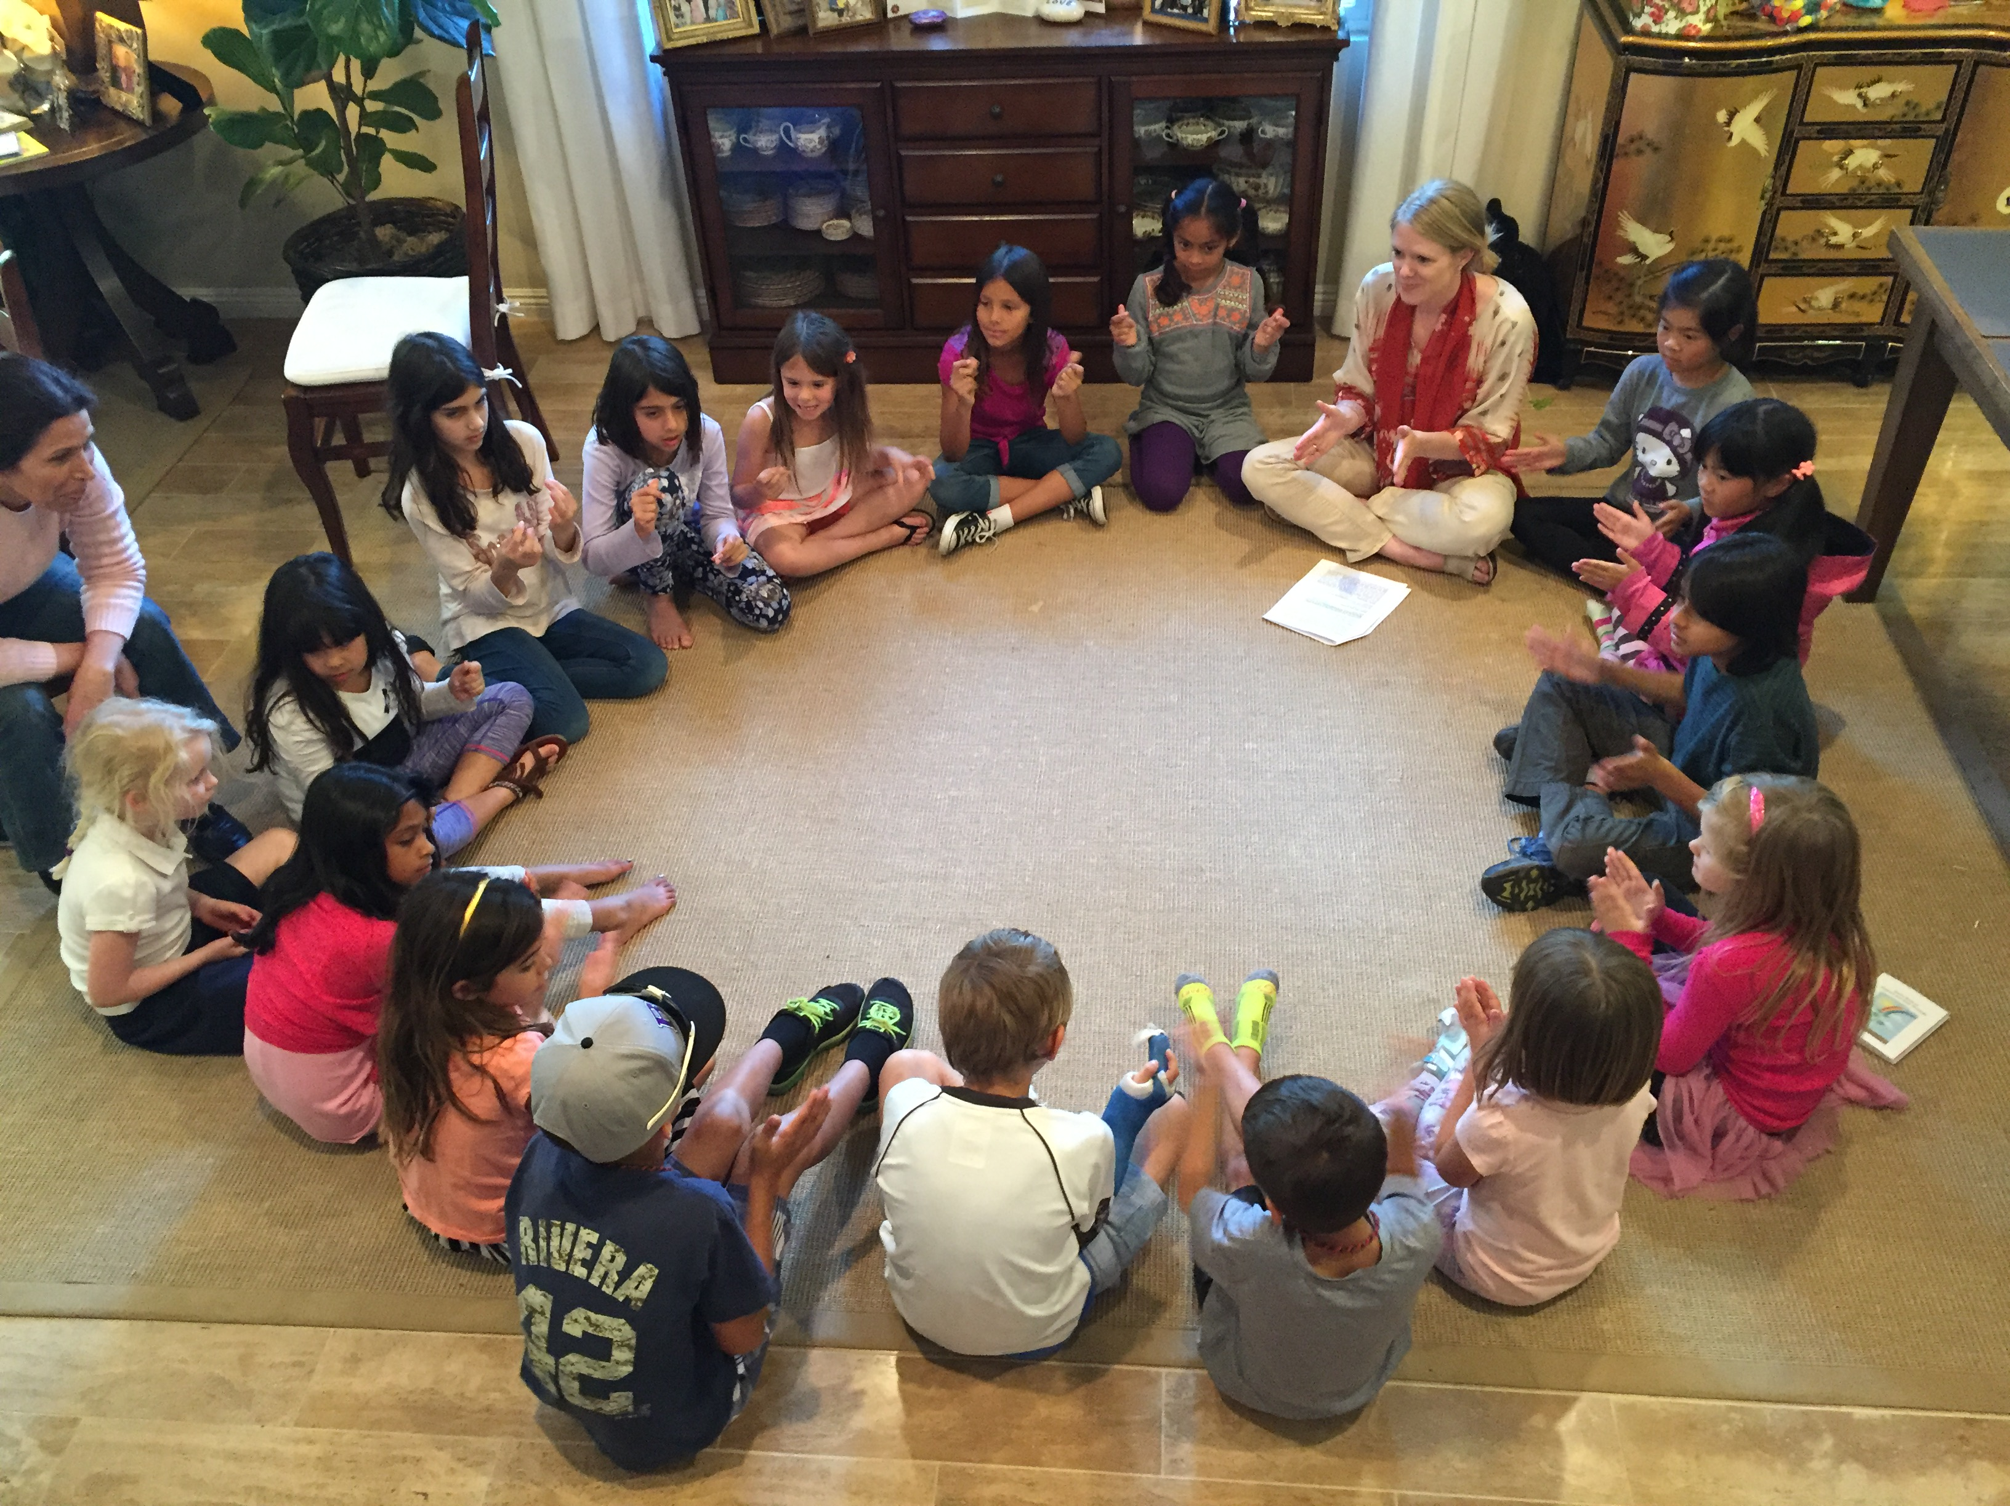
Habits and
Patterns of Conduct

