**“Blessed is he who mingleth with all men in a spirit of utmost kindliness and love.”**

**–Baha’u’llah**

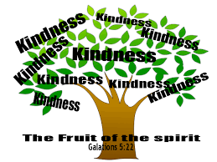

**“Blessed is he who mingleth with all men in a spirit of utmost kindliness and love.”**

**–Baha’u’llah**



**“Blessed is he who mingleth with all men in a spirit of utmost kindliness and love.”**

**–Baha’u’llah**



**“Blessed is he who mingleth with all men in a spirit of utmost kindliness and love.”**

**–Baha’u’llah**