Tiny Seed Songs
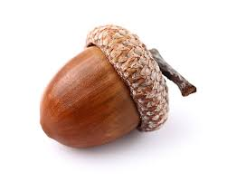
Tiny Seed

I am x 2
O my God x 2
But a tiny seed, which Thou hast sewn in the soil of Thy love
In the soil of Thy love

Tiny Seed Clapping Song

I am xxx
O my God xxx
But a tiny seed xxx
Which Thou xxx
Hast sewn xxx
In the soil of the Thy love xxx
And hast caused to spring forth by the hand of Thy bounty…
I am xxx
O my God xxx
But a tiny seed xxx

