Generosity: Stone Soup (by John J. Muth, although there are other versions and authors)

As the teacher reads the story, she also is the director of the play, urging each character to act out their part, giving them specific stage directions and the lines they will repeat as actors in the stone soup play. Give each child as much opportunity to act, to speak, to show emotion. For example, as each child adds their vegetables to the pot, that child also gets to stir the soup.

Props

1. Hat for each characters, and name-tag for each role (so the narrator could remember who is playing which character): Monks (we used long sparkly scarves), Brave child, Scholar (mortor board),
Carpenter (hard hat), Seamstress (fancy dress-up hat), Tea merchant, etc. You can add more characters,
or change out the characters to match the hats you have available.
2. Three smooth stones, an easy size for a child to hold
3. Cooking pot and long wooden stirring spoon, "grill" or grate under the pot
4. Set of empty salt and pepper shakers
5. Vegetables that each person will bring to the pot. I purchased three of these ($8 each) at IKEA:
Cabbage, tomatoes, green onions, garlic, carrots, zucchini, mushrooms.
You could also make the food out of felt... there are many examples of felt food on pinterest.

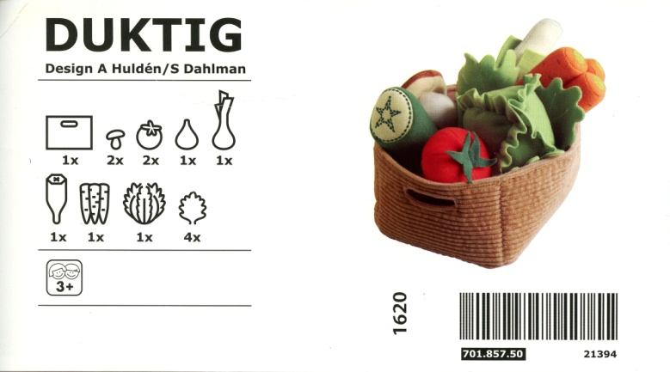

6. Plates, bowls or small baskets that each person uses to carry their contributions to the soup

Art Activity After the Story
1. Children make a collage as a reminder of the story

Materials
1. Card stock with memorization verse printed on the top or bottom of the page
(Be generous in prosperity, and thankful in adversity)
2. Pre-printed and cut outs copied from the book:
Stone-soup pot, 4 people bringing food, vegetables mentioned in the story that can go into the soup,
3. Glue

