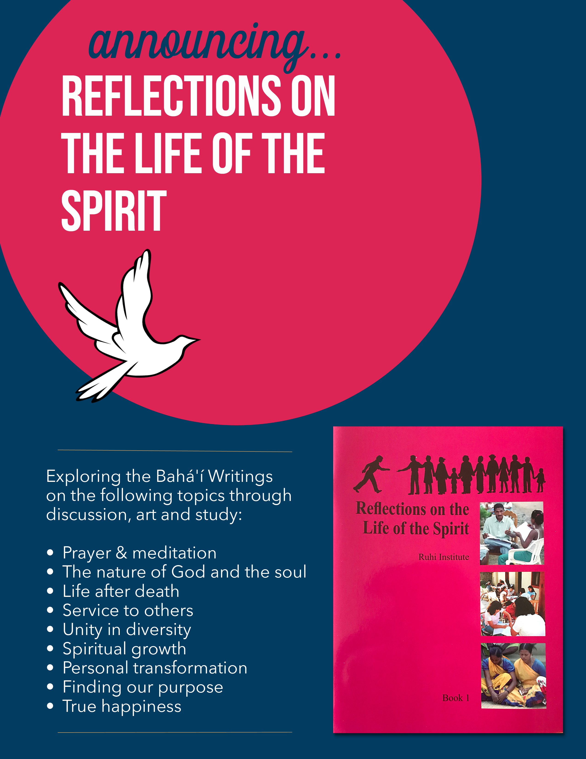

Thursday nights starting: May 9th from 7-9 pm

1234 Towne St, 99999

RSVP: (999) 999-9999