Courage: Paper Roll Dragon Craft

Source: onelittleproject.com by Debbie Chapman (slightly changed/adapted)

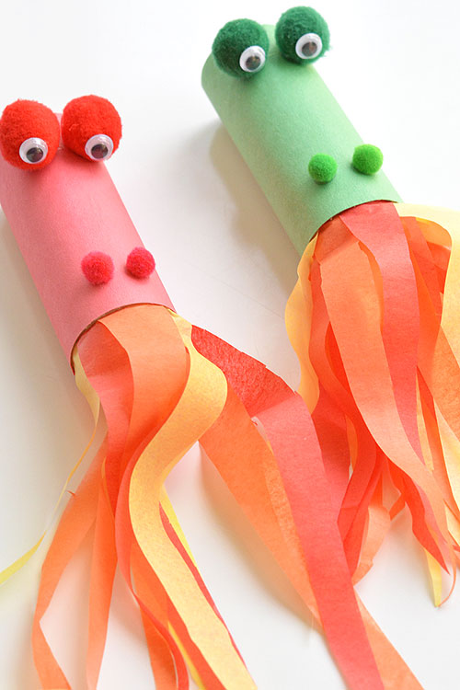
- Paper Roll (Toilet paper roll, paper towel roll, or wrapping paper roll)
- Green or Red (or any color) Construction Paper, cut slightly larger it extends 1/4 inch beyond the end of the tube.
- 2 Medium Pom Poms
- 2 Small Pom Poms
- 2 Medium Googly Eyes
- Red, Yellow and Orange Crepe Paper (tissue paper is too stiff and will not "blow")
- Tacky glue
- Optional: Glue Dots for eyes
Cut the colored paper slightly larger than the tube roll, so it will completely cover the roll, overlap so you can glue it around the roll, and extend 1/4 inch beyond the end of the roll on the 'eye' end, so you fold it down and make a softer edge.
Allow the children to select their colored paper, their colored pom poms, and
Let the children color the paper with their own designs to make it their own: scales, or anything they want.
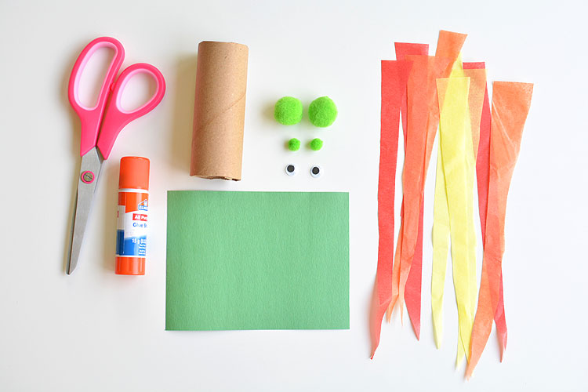

After the children color the paper, you can help the paper curl by sliding it under the edge of a tightly held ruler. Then glue it around the roll, adding more glue to the edge so it is very secure, and ask the child to pinch-hold the two ends until the glue sets. Then fold the 1/4 inch overlap to the inside of the roll. This creates a softer edge on the end the children will be blowing.
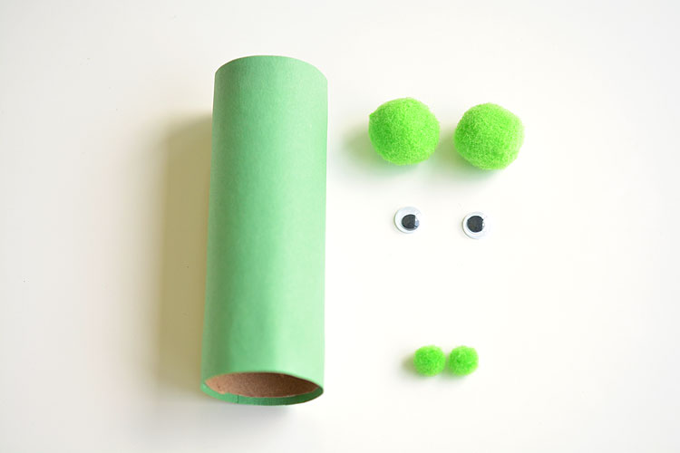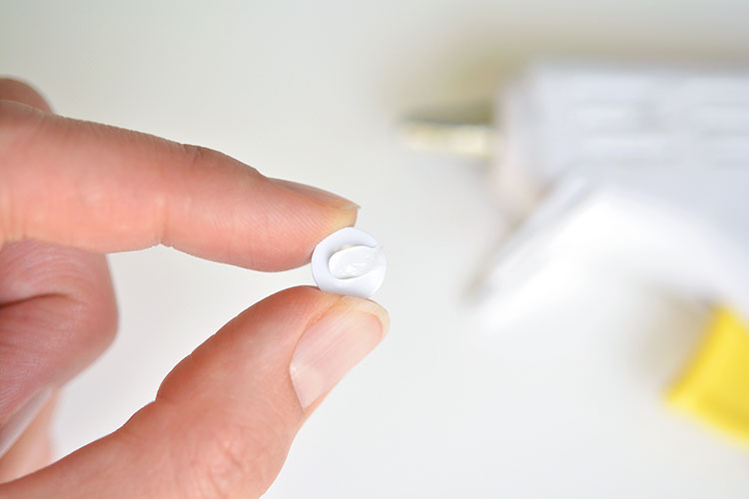

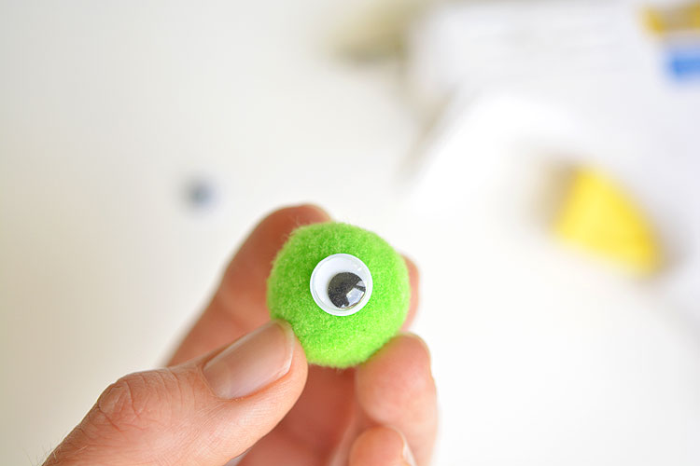
Attach the google eyes to the pom poms.

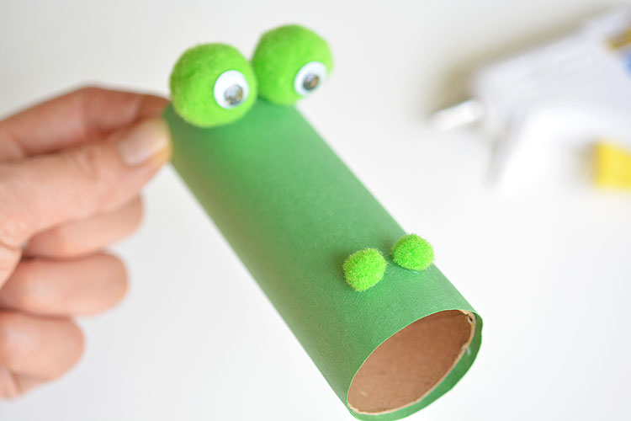

Next, attach the pom poms to the paper tube.

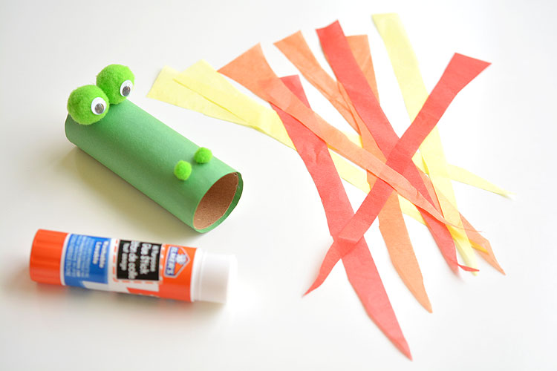

For the fire, used red, yellow and orange crepe paper, (not tissue paper as pictured here... crepe paper works much better) cut into 5 - 6 inch strips (not 8-inch strips as pictured here).

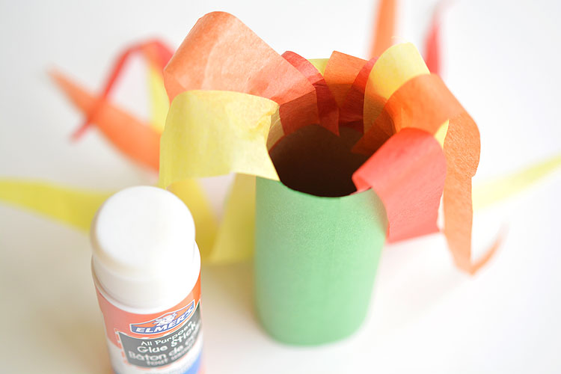
Run a bead of tacky glue on the inside of the paper tube, and one by one, the children can attach the crepe paper strips to the inside, draping them to the outside so they don't get tangled while gluing.

When the child blows through the tube, have them hold it tightly against their face (lips on the inside of the tube), so no air escapes. They will need to blow long and hard to get the paper flames to flutter.
