LESSON 12 ON HONESTY
Slightly modified from Ruhi Grade 1 curriculum

PRAYERS:
Prayer Sharers

Review of Prayers that they are learning
“O God, Educate…”
“I have committed…”

INTRO. OF NEW VIRTUE: All of us know of beautiful things that God has created to adorn our lives and bring joy to our hearts. Yet, more than material things, it is spiritual qualities that make human beings beautiful. One of the most beautiful qualities which can adorn our lives is honesty. When we beautify ourselves with honesty, we do not take things that belong to others without their permission, and we never deceive (try to fool) anyone.

MEMORIZATION: To help us remember the quality of honesty, let us memorize the following quotation of Baha'u'llah:

"Beautify your tongues, O people, with truthfulness, and adorn your souls with the ornament of honesty."

Beautify:
1. Malit planted beautiful roses in the garden. The roses beautify the garden.
2. Sunil used to tell lies, but now he only tells the truth. Sunil beautified his tongue with truthfulness.

SONGS:
Truthfulness
Truthfulness is brighter than the light of the sun x2
With truthfulness, O people, beautiful your tongues x2

Honesty adorns the soul of everyone x2
Honesty is brighter than the light of the sun x2

Truthfulness Song from Virtues in Us CD- School Age (available through www.cdbaby.com)

GAMES

Game: "Square, Circle, Triangle"

It is assumed that the children know the names of least a few shapes, for instance, "square", "circle" and "triangle". Begin by reviewing the names of these shapes with the children, making sure that they can identify each one. Next hold up a card on which you have drawn a sequence of three shapes - and tell them to look at it closely. Then put the card away and ask one of the children to say the sequence out loud. You should do this several times, using cards on which you have drawn a variety of sequences beforehand. VARIATION- do with movements

Build truthfulness tower

ART and CRAFTS
Honesty ornaments

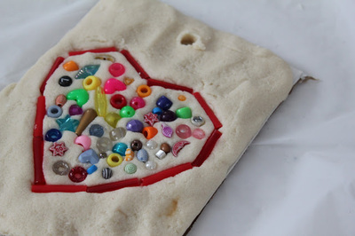
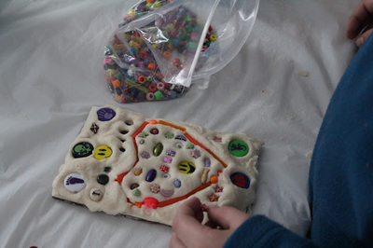

Ornaments on Honesty - from HERE.
- First, we made individual trays of salt dough - equal parts salt, flour, and water.
- Once their dough was sufficiently mixed, they pressed it onto pieces of cardboard. We used a cookie cutter to make a heart shape (to tie in the idea that honesty is one way we show love to others). Then I had them pick one colour from a big stash of beads to outline their hearts.
- After that, they used beads to create their own unique mosaic inside and outside the heart.
- Finally, we punched a hole for the kids who wanted to hang their ornaments, and sent them home in a Ziploc bag (the crafts, not the kids). They'd air dry them at home.

What is Honesty?
Being honest is being sincere, open, trustworthy, and truthful. When people are honest, they can be relied on not to lie, cheat or steal. If they tell you they like you, you know they really mean it, because they would not say anything just to get their way or to make an impression.
If someone seems friendly, honesty means they really are friendly, just because they want to be friends, not for any hidden reasons. With honesty, you can trust things as they appear to be.
Honesty is telling the truth no matter what. It is being truthful even when admitting the truth could make someone disappointed. Honesty means not exaggerating something just to impress others.
Being honest mean you don't make false promises. You do what you said you would do. Your actions match your words. This is also called integrity.

Why Practice Honesty?
When someone lies, cheats, or steals, people around him can't trust him. If someone makes up stories to cover up a mistake, it's hard to correct the mistake. Then he feels worse and worse about himself.
Have you ever heard of false advertising? That's when people try to sell something by lying or exaggerating. How would you like to spend money on something and then find out that it doesn't do what it is supposed to do - like a toy that doesn't really work. Without honesty people would always have to be suspicious.
Sometimes people aren't honest with themselves. They try to pretend that something doesn't matter even when it really does - like hurting someone's feelings. When someone isn't honest with herself about something, she usually isn't honest with others.
Honesty keeps you from deceiving or fooling other people just to get what you want. Honesty helps you not to fool yourself either. When you are honest with yourself, you have a change to correct your mistakes. When you are honest with others, they know they can believe you.

How Do You Practice It?
Match your actions and your words. Avoid deception - don't try to fool anyone and don't let them fool you.
Say what you mean and mean what you say. When you do something, give it your best effort, and then don't pretend you did more. Don't say or do things just to make a good impression. You don't need to make things up to look good - you're quite fine as you are, honest!
Only make promises you can honestly keep. Be trustworthy in all your dealings, refusing to lie, cheat or steal.
Use your imagination, but don't let it keep you from telling the truth.
Tell the truth, no matter what. If you make a mistake, admit it. It's the best way to fix things. Be honest with yourself, and you will always be able to be honest with others.

What would honesty look like if...
- You broke one of your mother's favourite things by accident and are afraid she will be angry?
- You find yourself exaggerating about how well you did in a sports game to impress your friends?
- Your sister asks you if a new dress looks good on her, and you think it looks pretty bad?
- You say something cruel to someone when you're mad and then tell yourself he deserved it?
- You forgot to do an important homework assignment and the teacher asks you where it is.
- Some friends of yours try to convince you to steal some candy from a store?

Signs of Success
Congratulations! You are practising honesty when you...  - Say what you mean and mean what you say  - Make promises you can keep  - Admit your mistakes  - Tell the truth tactfully  - Refuse to cheat, lie, or steal  - Are true to yourself and do what you know is right. | Keep trying! You need more practice when you...  - Lie, cheat, or steal  - Think you have to exaggerate to be important  - Cover it up when you make a mistake  - Promise to do things and then "forget"  - Fool yourself or permit others to fool you  - Hurt others by being honest without tact or kindness

AFFIRMATION
I am honest. I have integrity. I tell the truth, kindly or tactfully. I have no need to impress others or follow the crowd. I do what I know is right.

From The Family Virtues Guide by Linda Kavelin Popov

