Flower Care

Daffodils
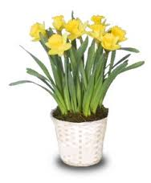
Place daffodil pots near a window so the plants receive bright but filtered light. Direct sunlight can burn the foliage and also causes the blooms to fade more quickly. Maintain a temperature between 50 and 70 degrees F in the room to further prolong bloom.

Check the soil in the pot once or twice a week. Water the daffodils when the top inch of soil begins to feel dry. Empty the tray beneath the pot 30 minutes after watering, otherwise the soil absorbs the water and becomes too soggy.

Snip off the spent daffodil flowers beneath the swollen flower base after the blooms fade. Leave the remainder of the stems on the plant because they continue to collect energy and nutrients for the bulb.

Fertilize the soil with a soluble balanced fertilizer once every two weeks after the last flower fades if you plan to transplant the bulbs. Apply the fertilizer at half the label's recommended rate.

Move the pots outside to a full sun location after frost danger is past. Cut off the foliage after it yellows and dies back naturally, usually six to eight weeks after flowering.

Transplant the bulbs to a well-drained garden bed that receives full sun exposure. Plant daffodil bulbs with the pointed tip 2 inches beneath the soil surface, and space bulbs about 5 inches apart. They remain dormant through summer and winter, producing new foliage and flowers in spring.

Zygo Cactus (Christmas Cactus)
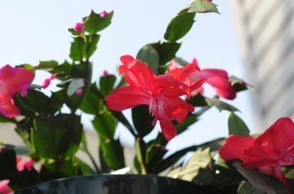
The Christmas cactus will adapt to low light conditions, but the plant will produce blooms more readily if exposed to brighter light. That being said, too much direct sunlight can burn its leaves, so keep the Christmas cactus in an appropriate area to avoid this.
Christmas cactus moisture is important as well. The plant requires frequent and thorough watering, during its active growth in spring and summer, keeping the soil slightly moist. Allow Christmas cactus moisture levels to drop and dry out some between watering intervals, but never completely, and never let the plant sit in water, as this will lead to root and stem rot. Keep in mind it also prefers temperatures hovering between 60 and 70 degrees F. (15-21 C.) with average to high humidity levels. Placing a tray of pebbles filled with water beneath the Christmas cactus container is a good way to add more humidity to the home.

Once the Christmas cactus has ceased all flowering (usually by fall), or about six to eight weeks before you want the plant to rebloom, you should allow the plant to begin its dormancy cycle by cutting back on Christmas cactus moisture and reducing both light and temperature. Simply cut back the watering and make sure the plant receives 12-14 hours of darkness and average temperatures around 50-55 F. (10-12 C.).
Also, keep the Christmas cactus away from drafty areas.

Tulips
Water the tulips when the soil is dry to the touch. Make sure that your forced tulips remain out of direct light and drafts. Tulips that have been forced to grow in a pot are usually exhausted from the effort and will not bloom next year, even if you plant them in the garden. They may bloom in subsequent years.
Cyclamen
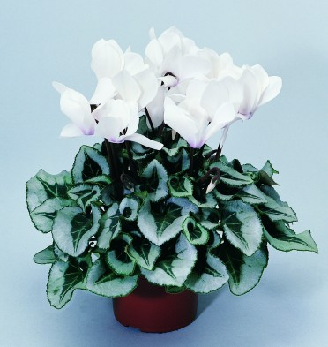
In your home, Cyclamen like to be a little on the cooler side with temperatures around 61˚F and in direct light or bright indirect light.

While in bloom, keep the root ball moist and feed the plant every two weeks. Cyclamen should be kept moist by watering in a tray and allowing the roots to take up the water rather than watering from above the plant which can lead to rotting. Remove yellow leaves and spent flowers.

When cyclamen are done blooming they can be discarded or the corm can be saved. After the foliage dies back, the plant should be left to dry. The corm should then be dug and repotted in midsummer and placed in a warm place so it can establish roots before returning it to a cool 55 - 60˚ F. to encourage flowering.

Shamrock
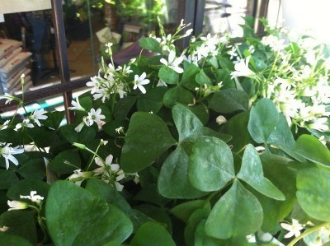
Shamrocks are bulb plants and die back after they bloom; but don’t throw them out, they just need a little rest before starting to grow again.
Light: Shamrocks need bright indirect light from an east or west-facing window.
Water: Keep the soil of a Shamrock barely moist but never soggy. Allow the top 2” of soil to dry out before watering. It’s always best to water a Shamrock from the bottom so that the thin fragile stems of the plant don’t get water logged and the soil stays loose.
fertilizer: Feed a Shamrock Plant monthly in the spring and summer when it is actively growing, use a basic houseplant food at ½ the recommended strength. Never feed a Shamrock Plant when it is dormant and the bulbs are resting.
Temperature: Shamrock Plants like cool temperatures and do best when the temperature is 60-70 degrees during the day and 55-65 degrees at night.
Humidity: Basic house-hold humidity is fine for this plant.

Ranunculus
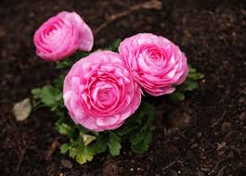
A sunny position is essential for ranunculus and a rich, well drained soil is required for good results. They should come back every year in a good climate but they definitely do better outdoors than inside.

African Violets
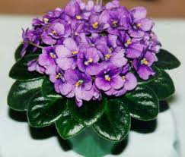
Water from the bottom with room temperature water by placing the plastic grower's pot in water, and allowing the plant to absorb the water ( not more than 30 minutes ). Avoid getting water on the leaves as this can cause spotting damage. Wait until the top inch of soil feels dry to the touch before watering again.
Avoid putting African violets in direct sunlight, which can yellow and burn the leaves. A window facing north or east is usually the best, especially during the summer. For more even growth, turn the plants occasionally so different sides face the light.

