Fireworks in a Glass
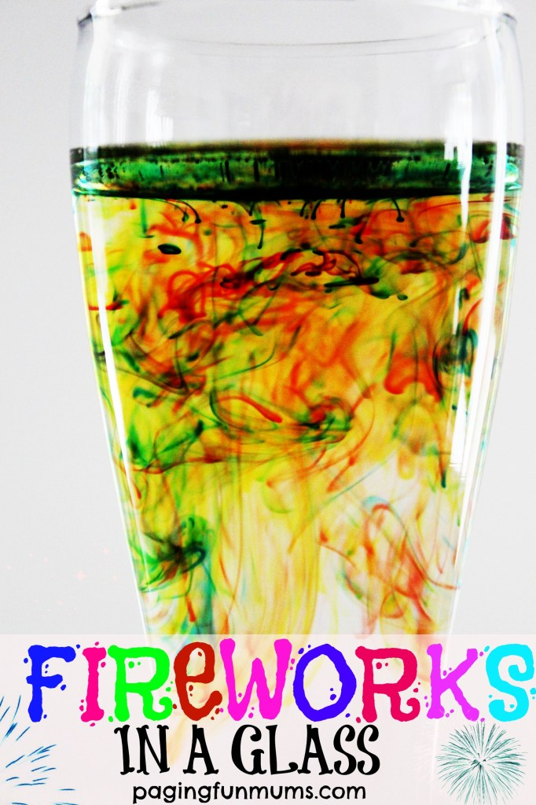
To make your own you will need:
Food colouring
Warm water
Oil (vegetable, olive, peanut – any will work)

Directions
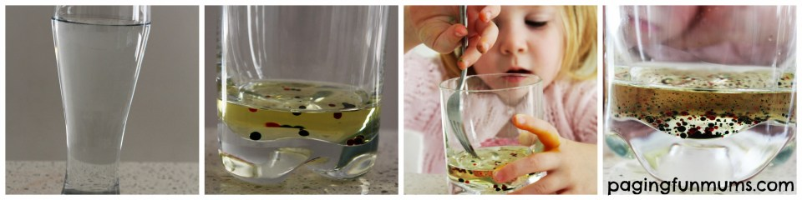Step 1
Fill a glass 3/4 of the way to the top with warm water
Step 2
In a separate glass add a few table spoons of oil and add 4 drops of food colouring – of differing colour
Step 3
Using a fork, give the oil and food colouring mixture a good mix to break up the ‘colour beads’ into smaller ones
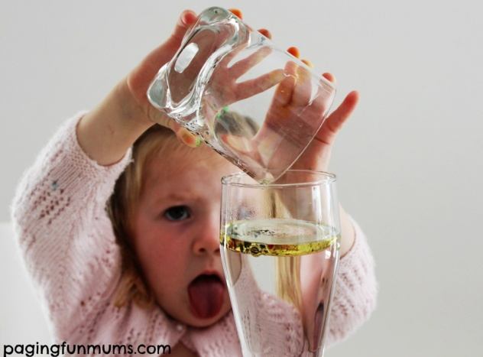
Step 4
Carefully pour the oil & food colouring mixture into the glass of warm water and wait for the magic to happen!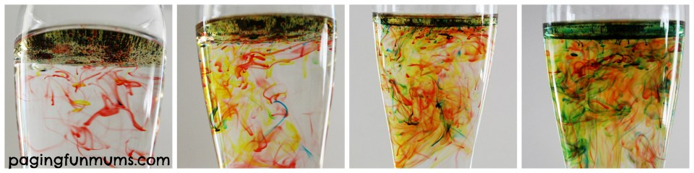

We did this over and over and OVER again and the kids couldn’t get enough to it…the photos barely do it justice too…it really is quite amazing how the coloured patterns form!
How it works “Food coloring dissolves in water, but not in oil. When you stir the food coloring in the oil, you are breaking up the coloring droplets (though drops that come into contact with each other will merge… blue + red = purple). Oil is less dense than water, so the oil will float at the top of the glass. As the colored drops sink to the bottom of the oil, they mix with the water. The colour diffuses outwards as the heavier colored drop falls to the bottom”

