EASY KITE MAKING INSTRUCTIONS FOR PRESCHOOL KIDS
From: < http://foodfunfamily.com/kite-directions-for-preschool/ > .Tuesday, March 9, 2010 by Lolli
2k
Shares
Spring is a great time to fly kites. I found a fun and easy kite making pattern* that is perfect for kids (today kids 2 to 9 used these kites!). They decorated their papers first before following these instructions to “assemble” their kites:

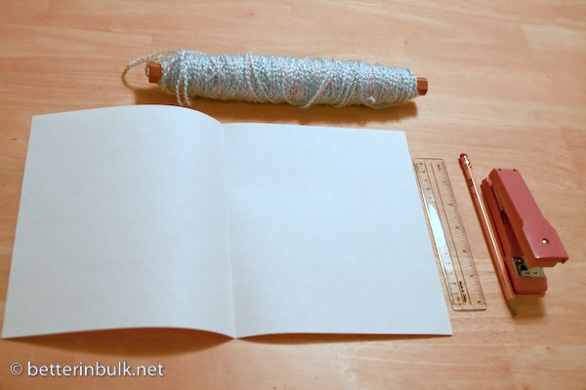

Step 1: Gather materials (one piece of Brightly colored paper, a ruler, a pencil, some yarn or string, a stapler, and a hole punch). You can pre-print a design on the paper that the child can color in Step 3, or have them make up their own design.
Step 2: Fold paper in half

Step 3: Have the child create a colorful design on the paper with markers or crayons.

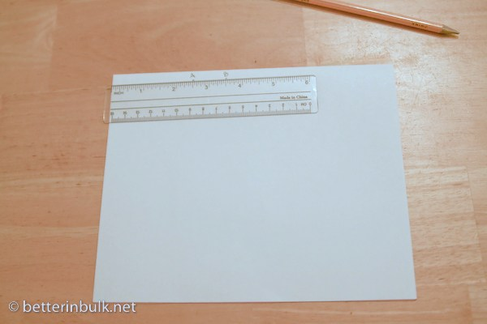
Step 4: Along the folded side of your paper, measure and mark off at 2 1/2 inches (point A) and at 3 1/2 inches (point B)

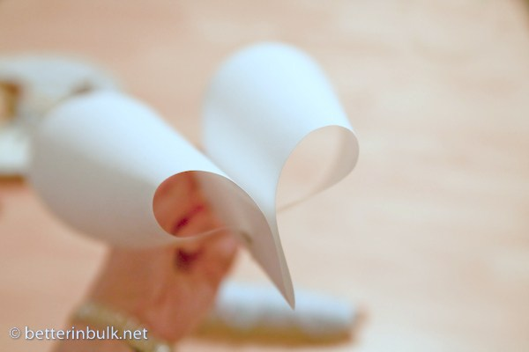

Step 5: Take two corners of your paper and staple them together at point A.
Step 6: Punch a hole at point B

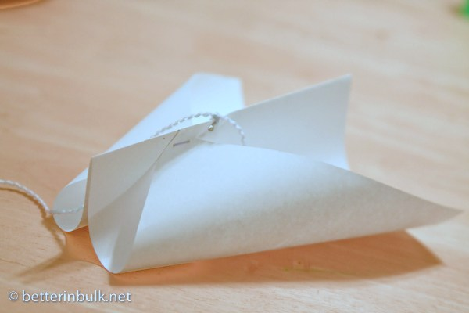
Step 7: Tie a long piece of yarn through the hole you’ve just punched.
Step 8: Fly your kite on a windy day, or if the day is calm, the child can run very quickly holding the string up high, and the kite will fly.
Step 9: Expect lots and lots of laughs, “Wows!” and running around.
These simple kites were so easy to make, and even easier to fly. I’ve never had a kite take to flight so easily or stay up for so long. Even the 2 year old could do it!
*Note: someone asked where I found this kite pattern. I actually stumbled upon it offline (back in the days when I had preschoolers and swapped ideas with other parents in the community). I know this isn’t an original idea, but we sure had fun making it and wanted to share! Enjoy!

