DIY SOCK PUPPETS
JULY 22, 2015 BY ALLI
<http://takingcareofmonkeybusiness.com/blog/2015/07/22/diy-sock-puppets/#_a5y_p=4089120>

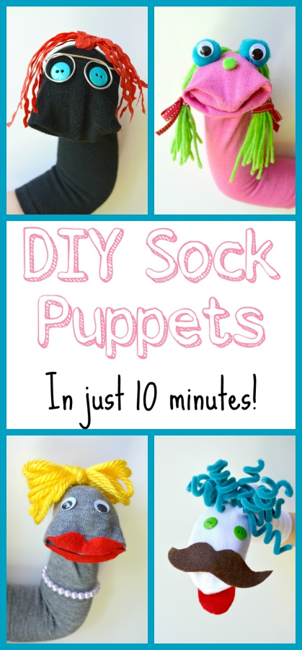
Unfortunately, my monkeys are too young to work a glue gun, so I had to do most of the work for these. But Soph had input on style choices and colors
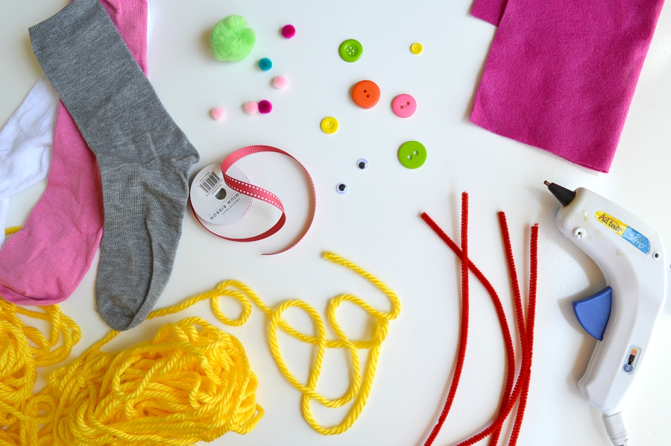
The great thing about these puppets is that you can do whatever you want with them!
Let your creativity run wild. For materials, we used:

Socks
Hot glue gun
Scissors
Felt
Wire
Needle/thread
Yarn
Rickrack
Pipe cleaners
Buttons
Pom poms
Ribbon
Googly eyes
Plastic pearls

Other than socks and hot glue, the rest is pretty much up to you – just use whatever you find lying around your house

For this puppet, I cut out some lips with felt, and glued those on. Then for the hair, I made a loop of yarn (like how you would loop a hose in a circle to put it away), then tied the loop into a knot, which made for a nice bow. The necklace is made from some plastic pearl beads on a pipe cleaner, but I think it would’ve been even better had I used some stretchy elastic.

This one is pretty simple – the tongue and mustache were cut out of felt, and the hair is made of pipe cleaners. I was able to thread the pipe cleaners through the sock, using the metal ends as a needle. Then I wrapped them around a marker to make them curly!

This one took the longest to make, but was still very easy. The eyes are just googly eyes hot glued onto pom poms. For the hair, I threaded the yarn onto a large needle and sewed it into the top of the sock (just going in and our of the sock once). When I had enough hair, I trimmed it all to the same length, and hot glued the inside of where the hair was, to keep it in place. Finally, I finished it off with some bows tied with ribbon.

This puppet may be simple, but I still love it. The hair is strands of rickrack that I tied into a knot and glued on top. The eyes are buttons, and the glasses are made from wire. Just use a wire that isn’t super thin, and bend it into the shape of glasses, and hot glue them on.

