DIY RAINSTICK TOY FOR SENSORY PLAY
To make one you need:
- A paper towel roll
- Bamboo skewers
- Scissors and/or a gardening trimmer
- A nail
- Duct tape
Here’s how to make one:
Step 1: I used scissors (junky ones – cutting skewers is probably hard on good scissors) to cut bamboo skewers into 3 pieces each. Cutting with gardening clippers would be even better.

Step 2: I poked holes in a paper towel roll with a nail. I made sets of 2 holes across from each other so that a skewer piece could go all the way through. I used the pointy end of a skewer to make each hole larger and then slid the skewers into place. The more skewers you use, the better the sound will be!

Step 3: I used gardening clippers to trim off the excess bamboo skewer ends.

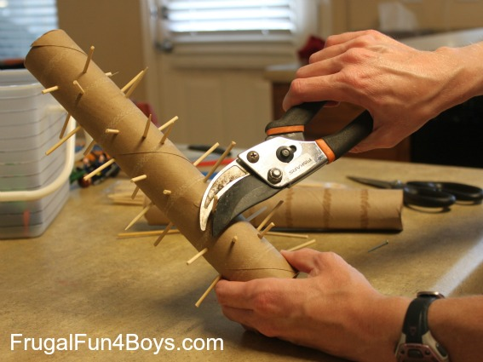

Step 4: Since the gardening clippers didn’t cut super close to the paper towel roll, I covered the whole thing with a generous layer of duct tape to get rid of the poky edges.

