Friendliness
Crafts: My Friendship Garden

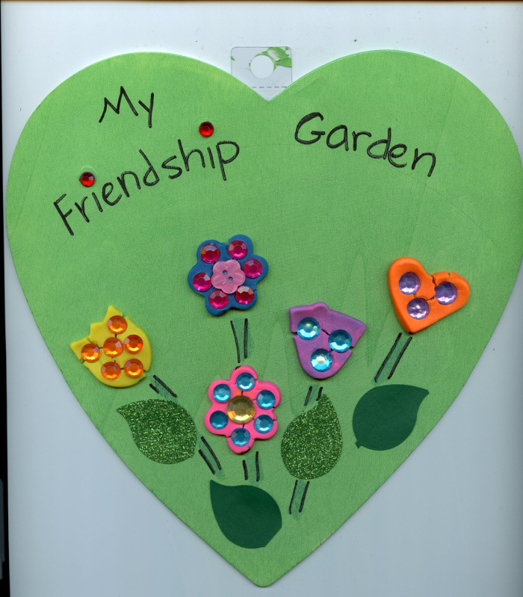

Materials
1. Heart-shaped plaque. Other shapes would also work. I left the clear plastic 'hanging loop' at the top.
I bought ours at Michaels "ArtMinds Wood Heart", 1/8 inch thin plywood, 8-1/2 x 8-3/4, for $1.39 each.
(http://www.michaels.com/artminds-wood-heart/10352994.html#q=wood+heart&start=20)
2. Light green acrylic paint to paint the heart
3. Sharpie marker to write "My Friendship Garden" on the top
4. Several colors of play-doh for the flowers
5. Cut-out green leaves, about 1-1/2 inches in length
(I used sparkly and regular card-stock, and a large leaf punch from EK tools,
but they could also be cut by hand, or use a large heart-punch and cut the hearts in half to make leaves)

(EK Tools 54-31013 Paper Punch, Green Leaf, Punches 1.5-Inch)

6. Glue

7. Small rolling pins (or children could just press the play-doh flat with their hands)

I bought the rolling pins at Michaels, 3 per package, but currently I don't see them on their website.

8. Small (1/3 inch - 1/2 inch acrylic gems) to decorate the flowers. Again, from Michaels.

9. Optional: Craft-tray (to keep the mess from spreading too far)

10. Parchment paper (the children can press or roll the play-doh on the paper, for each removal)

11. Flower-shaped cookie cutters (again, Michaels, although don't see the sets on their website)

12. Green markers for drawing "stems" for the flowers

Prep before class

1. Paint the hearts on one side, light green

2. Write "My Friendship Garden) across the top

Directions

1. Each child can select their play-doh colors. Adults can help by pinching off a walnut-sized piece and showing the child how to roll it into a ball, then child can flatten it with their hand or rolling pin onto the parchment paper, and cut out flower.

2. After all the flowers are cut out and arranged placed on the wooden heart, adult or child can lift them (one by one) and put a large drop of glue on the back of the flower, then replace it onto the heart.

3. Child can select and press gems into the flowers.

4. Child or adult can draw "stems" with markers

5. Child can glue leaves onto the wooden heart.

