Friendliness
Crafts: Bucket Necklace to accompany story "Have you Filled a Bucket Today?"

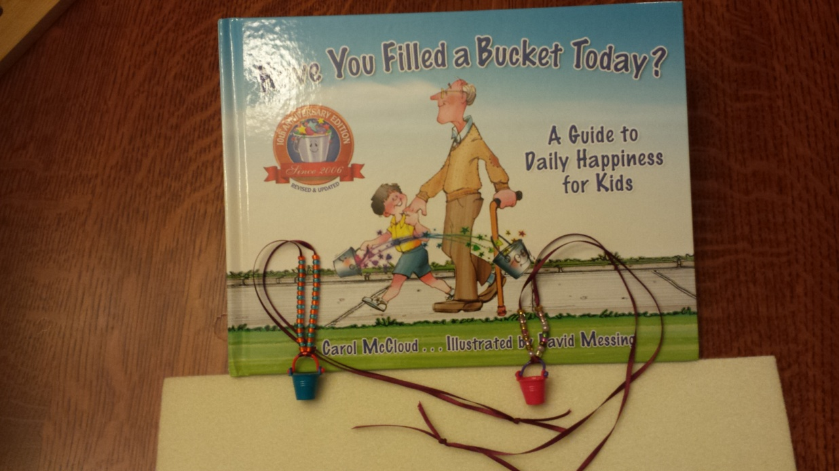

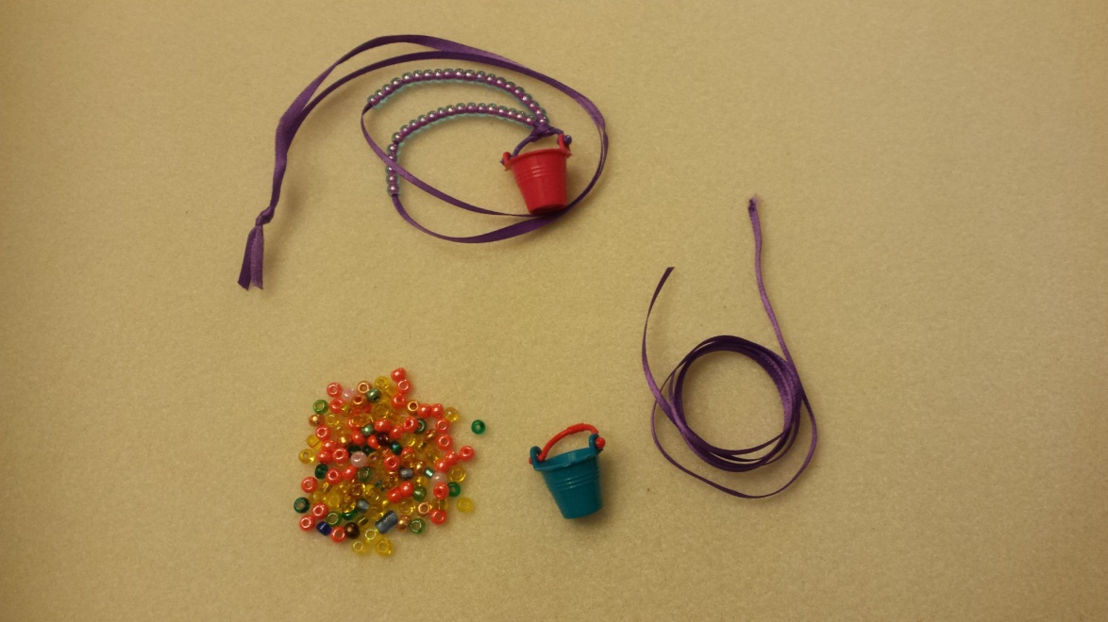

Materials
1. Beading mats (help keep beads from scattering). You can use a felt-square for a beading mat
2. 1/8-inch satin ribbon for each child, about 22 inches long
3. Needle and thread for each ribbon
4. #6 beads of various colors
5. Miniature "buckets"
(Michaels, "Sparrow Innovations Miniatures, Bright Plastic Buckets, set of 6 buckets for about $3)
http://www.michaels.com/10314271.html#q=miniature+buckets&start=1

Prep before class:

1. Thread needle with about 10 inches of thread, double, and tie around the ribbon about 4-6 inches from end

2. Into each child's zip-lock snack bag place the satin ribbon, needle and thread, and tiny bucket.

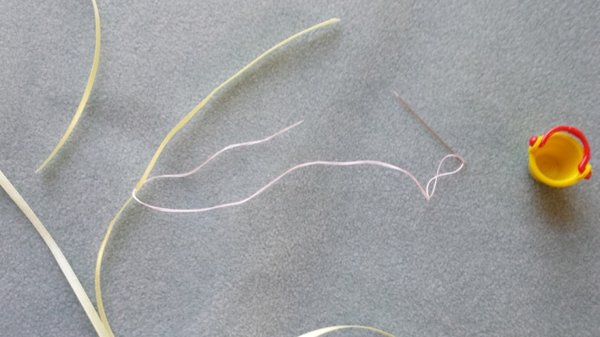

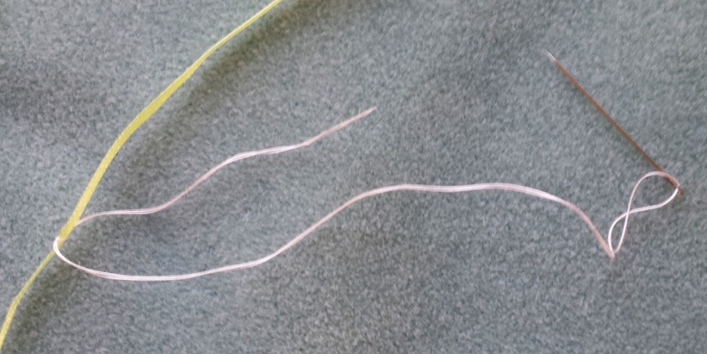

Directions

1. Each child can select one or two colors of beads. Pour a dozen or so beads onto their beading mat.

If you allow the child to pour the beads, they can end up all over the floor and clean-up is more difficult.

2. Show the child how to thread one bead onto the needle, then slide the bead down the thread over the

doubled satin ribbon, one bead at a time. Sometimes the bead-hole is so narrow that the bead will not slide over the doubled-ribbon, so just remove that bead and set it aside.

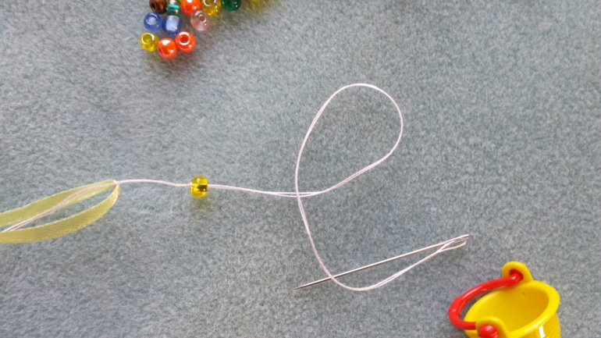

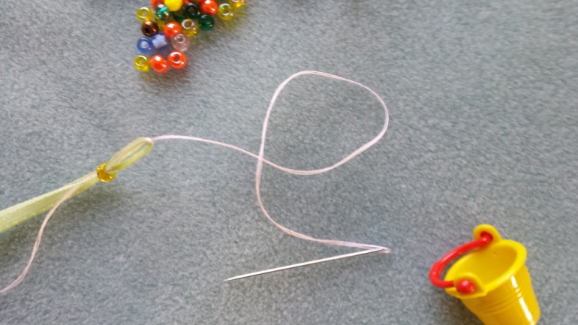

3. Our experience is that young children become bored after putting 6 to 20 beads on the ribbon.

However many beads to onto the ribbon is fine.

4. Pull off the needle-and-thread from satin ribbon by pinching the satin ribbon where the thread is tied,

and simply sliding the thread off.

5. Fold the satin ribbon exactly in half. Split the beads so half are on each side of the ribbon,

and push the beads up in the direction of the end, so that there is a loop of ribbon in the center

about 2-3 inches long. Thread this loop into the handle of the bucket.

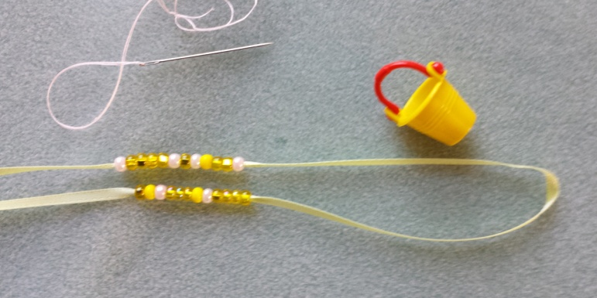

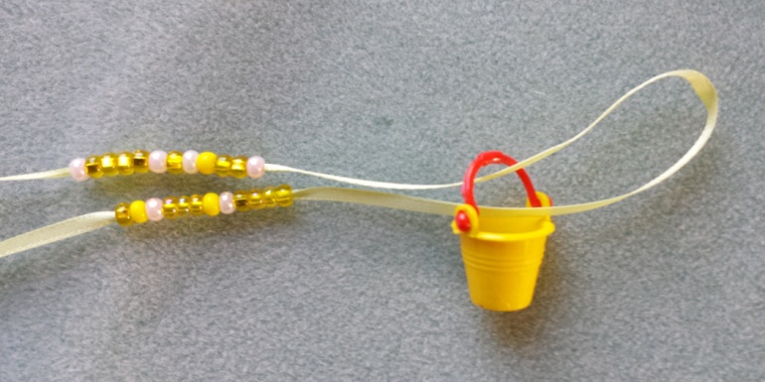

7. Loop the ribbon around the bottom of the bucket, then pull tight, to secure the bucket to the ribbon.

Then slide the beads back towards the bucket loop to secure the loop.

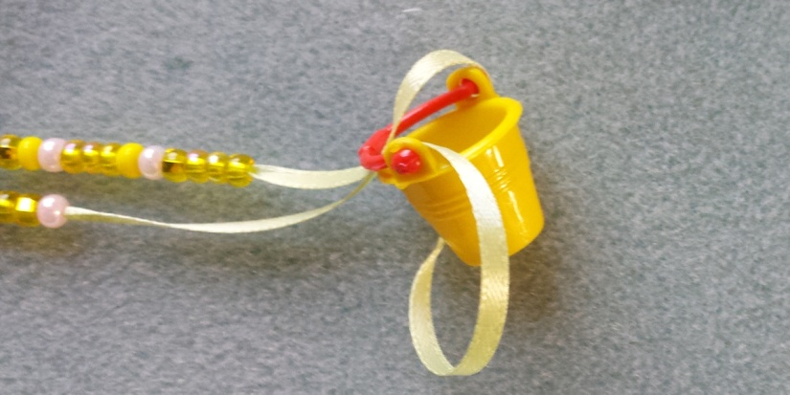

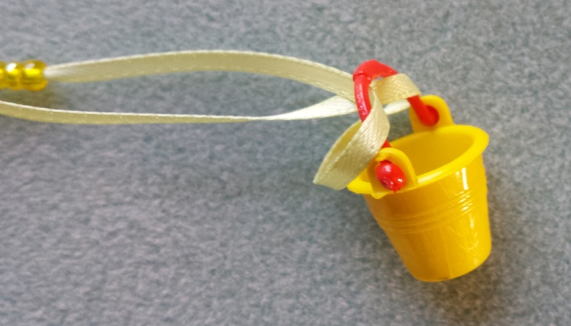

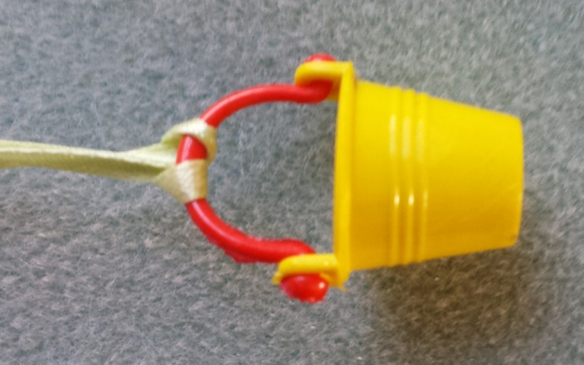

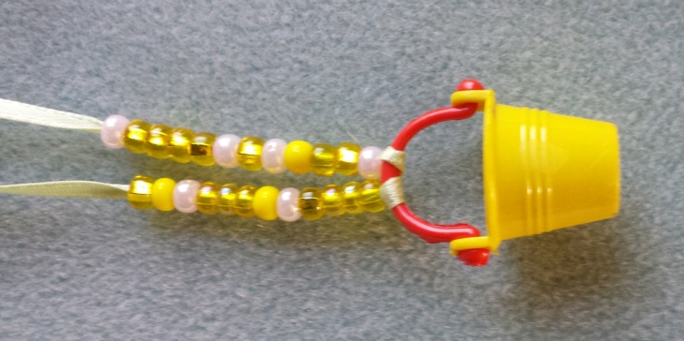

9. Holding the ribbon around the child's head at the largest diameter, pinch the ribbon, then tie a knot so that the length of the necklace easily slides over the child's head, but is not excessively long.

