Bluebird of Happiness Song

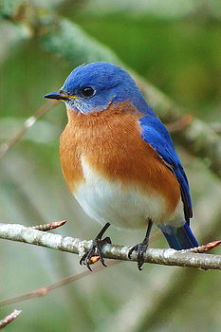
Chorus:
Let the bluebird of happiness
Fly to you and build its nest
Just let that bluebird into your heart
That's when the joy will start

Some people waste their time away
Complaining 'bout their problems night and day
No matter what they got, they still want more
Something's missing, they're not even sure

Chorus

If folks would take a look around
They'd see what's lost can still be found
That little bird's just flying and it's lookin' around
To find a place that it can settle down

Chorus

Some say true happiness comes from afar
But just take a look in your own back yard
And keep your eyes on that sweet little bird
Its song will be the sweetest one that you have ever
heard

Chorus

