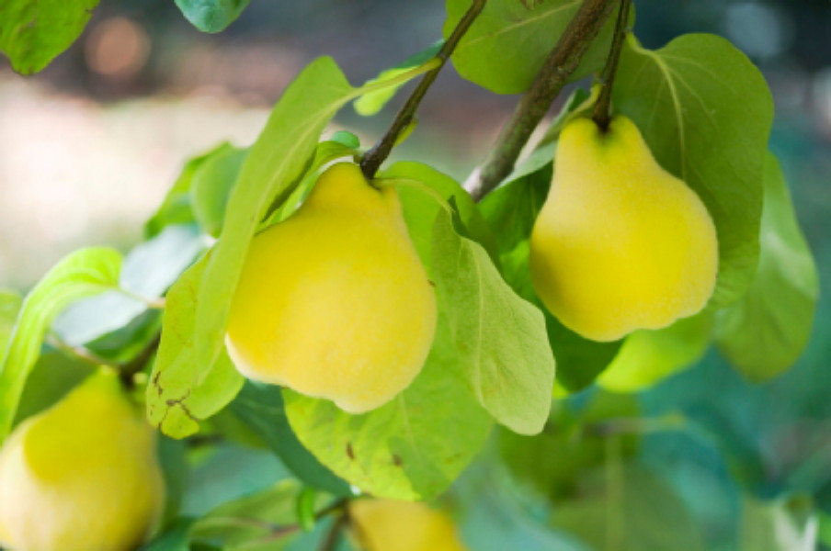

Be Like the Earth

See the earth
It’s so humble
Has all God’s wealth to give
Everything we need to live
Lets us walk on it every day
But have you ever heard it say
“I am richer
Greater than you”

See the tree
It’s so humble
The more its fruits abound
It bows closer to the ground
And shares the fruit that way
But have you ever heard it say
“I am richer
Greater than you”

Be like the earth
Be like the tree
Rise to the heaven of glory
On the wings of humility
Rise to the heaven of glory
On the wings of humility

